AOSN II Science/System Performance Summary

24 October 2002

Science Objective
- Long-Term Objective:
  - To develop an Adaptive Coupled Observation/Modeling Prediction System able to provide an accurate 3 to 5 day forecast of marine biology events, such as bioluminescence blooms, red tide events, or the health of important stages in the food chain.
- Current Year Objective:
  - To study processes and conduct science important to the long-term objectives discussed above. To do this while exploiting the coupled observation/modeling prediction system to conduct science that cannot otherwise be conducted.
  - To study the onset, development, and variability of a 3-D upwelling Center off Point Año Nuevo and in the Monterey Bay.
  - To further study the Center’s ecosystem response: physics, chemistry, and biology (including bioluminescence).
  - To understand the California current system and its interactions with coastal circulation, biological dynamics, and advection of the Center.
- Contingency Plan (TBD):
  - A contingency plan should be developed for use in the event that the upwelling center does not develop next summer due to, for example, the anticipated ENSO event.

Scientific Hypotheses
The AOSN-II System will be developed to test the Scientific Hypotheses listed in Table 1.

Table 1: Science Hypotheses
Hypothesis | Consequences | Action Items | Notes
Phy Sci. The evolution of the near-surface (0-200 m) upwelling plume is influenced by the stratification and vertical shear imposed by the California Undercurrent. | • Initialization fields must include extensive undercurrent observations.  • At least some measurements within the undercurrent must be conducted during the experiment. | • Ship time and/or deep rated gliders and/or AXBTs are needed.  • Profiling floats are to be considered.  • Deep rated gliders are to be considered. | • It would be possible to investigate output from the ICON model to better estimate the role of the undercurrent if desired.
Phy Sci. The evolution of the near-surface (0-200 m) upwelling plume is influenced by larger-scale meandering in the offshore California Current System. | • Initialization fields must include extensive observations offshore of nominal plume location.  • At least some offshore measurements must be conducted during the experiment. | • Ship time and/or deep rated gliders and/or AXBTs are needed.  • Ensure that models have adequate boundary information or, at least, ability to assess B.C. limitations. | • Potential payoff here from adding small number of deep rated gliders or AXBT and some additional aircraft time.
Phy Sci. Small scale (5-10 km) wind stress curl forcing is important for the circulation in and around Monterey Bay. | • High resolution wind forcing is required.  • Atmospheric observations capable of validating the forcing fields are required.  • Heat fluxes are required | • Include spatial wind mapping in aircraft program. | • The observations should be covered by the funded aircraft component.
Phy Sci. Tides are important in the near surface evolution. | • Plume sampling from most (or all) in-water assets will be aliased.  • Ability to compare observed and modeled locations (e.g., frontal positions) may be no better than a few kilometers. | • Use HF radar-derived surface velocity fields to estimate tidal-produced movements of surface properties in and around the upwelling plume. | • Tidal currents in region are dominated by internal tide.  • Adding tidal forcing to circulation models is not trivial and will require extensive validation if attempted.
Bio Sci. Nutrient supply to the upwelling plume, e.g., NO₃, controls the amount of primary productivity within the plume. | • Measurements of NO₃ on scales of the plume are required (Alternative: measurements of temperature and salinity calibrated for NO₃.).  • Additional sampling must be conducted to characterize biological fields.  • Inadequate measurement (or parameterization) of NO₃ may confuse assessment of ecosystem model skill. | • Discuss further with chemical oceanography partners to determine what are the minimal measurements that could help to test this hypothesis. | • Strong coupling here to output and capabilities of ecosystem model(s).
Bio Sci. Micronutrient supply to the upwelling plume, in particular Fe supply, controls the amount and/or species composition of the primary productivity within the plume. | • Measurements of Fe on scales of the plume are required (Alternative: measurements of sediment resuspension on the shelf at the base of the upwelling plume could be used to look for correlation with downstream productivity).  • Lack of measurement of Fe may confuse assessment of ecosystem model skill. | • Discuss further with chemical oceanography partners to determine what are the minimal measurements that could help to test this hypothesis. | • Unlikely to have in situ Fe sensors available.
Bio Sci. The source water seed populations control the biological community structure, in particular the bioluminescence constituents, in the region of the upwelling plume. | • Must measure biolum. both within the plume and upstream.  • Must know what direction is “upstream.”  • Biological sampling at the species level must be carried out in a range of locations inside and around the upwelling plume. | • Add biolum. sensors to gliders, ship, or vehicles. | • Strong role for modeling here to test this “advection dominance” hypothesis.
Bio Sci. Mixing and/or upwelling and subduction processes along the upwelling plume are significant factors in the distribution and total amount of primary production. | • Cross-plume measurements must be maintained at downstream locations in addition to the base of the upwelling plume. | • Add biolum. sensors to gliders, ship, or vehicles. | • Clear evidence exists for vertical processes along the upwelling front, but that does not guarantee a significant contribution from frontal processes.
Bio Sci. Biological assemblages can be partitioned by water mass properties within the region. | • Biological sampling at the species level must be carried out in a range of locations inside and around the upwelling plume. | • Collect some net-tow samples for biological characterizations. | • Much could be done post processing or with archival data once physical water masses are defined.
Bio Sci. Biological assemblages can be partitioned by water mass “age” within the region. | • Biological sampling at the species level must be carried out in a range of locations inside and around the upwelling plume. | • Collect some net-tow samples for biological characterizations. | • Much could be done post processing once physical circulation pathways are measured or modeled.
System. A combined modeling and observation network is capable of tracking the space-time evolution of the mesoscale upwelling plume that originates along the coastline north of Monterey Bay. | • Primitive equation model(s) must be configured with, approximately, 1 km resolution over 120 km alongshore by 80 km offshore domain.  • Accurate surface forcing fields must be available.  • Boundary conditions must be available from larger-domain models or from direct measurements. | • 9 km COAMPS atmospheric model output is required. | • Yi Chao and Rich Hodur are the COAMPS contacts.
System. Ensemble forecasts from a well-initialized model can be used to optimize future sampling. | • Complete, 3-D (full-depth) initial density fields must be available for the plume and surrounding waters.  • Incomplete initialization degrades the accuracy and utility of the ensemble forecast and forecast errors. | • Extensive ship-time must be funded and scheduled to conduct region-wide CTD surveys. (Alternate or Supplement: acquire deep-profiling gliders or floats and/or extensive AXBT resources.) | • Chavez / McMannus have arranged time on the Pt. Sur.  • AXBT deployments are not compatible with low-altitude SST mapping mission and may require additional flight hours.  • Pt. Sur. Plan must be updated to include bio sampling.
System. Multiple sampling assets can be guided in real time by model forecasts; Such guiding can be demonstrated to increase predictive skill. | • Real-time data retrieval and exchange is required.  • Adequate field observations of the shape, location, and intensity of the upwelling plume must be maintained throughout the experiment (tracking area is roughly 10 km x 20 km x 200 m deep). | • Data handling protocols and formats must be worked out. Adequate bandwidth to the in situ instruments and between the shore-side computers must be available.  • Adaptive sampling strategies must be worked out for the vehicles in question, in particular shallow gliders, in order to sample the evolving upwelling plume.  • Sample 3-D u,v,T, and S data from the ICON and JPL/ROMS model runs for summer 1999 and 2000 should be supplied to the sampling teams. | • A mechanism should be included to test the null hypothesis that random or predetermined sampling is inferior.
System. COAMPS atmospheric model forecasts and analyses using, at least, 9 km resolution are capable of capturing the important wind stress curl and diurnal, sea breeze variations in and around Monterey Bay. | • This experiment provides an important test-bed of the COAMPS atmospheric forcing product as part of the overall ocean predictive skill experiment. | • Entrain atmospheric research scientist(s) interested in evaluating COAMPS forcing fields. | • The observations should be covered by the funded aircraft component.
System. Improved 3-D fields of physical variables, including u,v,S,T, can be used to improve the modeling and forecasting of biological field variables on scales resolved by the model. | • Extensive mapping of biological properties (or proxies) must be made over the scale of upwelling plume (roughly 10 km x 20 km x 200 m deep).  • Test cases can also be constructed to test the secondary hypothesis that, for some species and time scales, pure advection and diffusion is adequate to predict downstream patterns and concentrations. | • Equip multiple gliders with fluorescence, backscatter and bioluminescence sensors.  • Use existing output from ICON model to study optimal positions for bioluminescence sections under various wind conditions.
System. Relatively simple, multi-component ecosystem models can explain the distribution and timing of primary productivity within the upwelling plume. | • Separate ecosystem models must be embedded within physical model(s).  • Additional sampling must be conducted to characterize biological fields. | • Equip aircraft with color sensor to allow repeated spatial mapping of biological fields on scales commensurate with SST patterns in and around the upwelling plume.  • Equip vehicles with Fl and/or other biological sensors. | • Recommend obtaining Hobi Labs HydroRad instrument for aircraft (approximate cost: 30K)  • Add Fl to gliders.

Observation Assets
The AOSN-II System will require the Observation Assets listed in Table 2. Responsible Scientists are identified where information is still required.

Table 2: Observation Assets
Asset | Use | Cognizant Team Member | Instruments | Sample Grid | Data Update Method and Interval | Ship Time Required | Issues | Status | Notes
ADCP
ADCP (bottom mounted) | Assess undercurrent | Ramp | ADCP |  |  | John Martin to deploy and recover. | Requires Telesonar network to communicate to shore. | Not Avail. | Not currently part of AOSN-II plans. Ramp may be able to make available if required.
Aircraft
Twin Otter | Surface MET, SST | Ramp | SST, Radiometer, Hyperspectral |  | 4 hour flight. Data avail within 2 hrs post flight | None | Hyperspectral Not Funded
Pelican | Surface MET, SST | Ramp | SST, Radiometer, Hyperspectral |  | 4 hour flight. Data avail within 2 hrs post flight | None | Hyperspectral Not Funded
AUV Gliders
WHOI Gliders 1-5 | Near shore measurements and Adaptive Sampling studies | Fratantoni | Fluorometer, OBS, PAR, Biolum (2 only) | Near shore fan blades | TBD | John Martin | Need to get DURIP funded for fluorometer and OBS on gliders 4&5 |  | Limited to 200 m. Data will be QC’d and available in 10-15 min. Full simulation capability already exists
WHOI Gliders 6-10 | Off shore measurements (fan blades) | Fratantoni | Fluorometer, OBS, PAR | Off shore boundary mapping | TBD | John Martin | Need to get DURIP funded for fluorometer and OBS |  | Limited to 200 m. Data will be QC’d and available in 10-15 min. Full simulation capability already exists
WHOI Gliders 11-13 | Spares | Fratantoni
Deep Rated Gliders | Off shore deep water measurements | TBD |  |  |  |  | Not currently planned
AUVs
DORADO 1 | SPOKES transects | Haddock |  | SPOKES transects
DORADO 2 | C1-M1 transect | Chavez |  | C1-M1 transects
NPS AUV |  | Healey
Cal Poly REMUS |  | Moline
AVIRIS |  | Ryan |  |  |  |  | Not available but Phils may be
AXBT | Assess Boundary Condition | Ramp |  |  |  |  | Not currently planned
COAMPS |  | Hodur
CODAR |  | Paduan |  |  |  |  |  |  | Covers Monterey Bay out to M2. New sites may cover Pt. Sur and Davenport upwelling filaments.
Drifters (Surface)
Drifter 1-5 with spares |  | Chavez | CTD, C02, GPS | Off Shore |  |  | Requires $$ for fluorometer/backscatter (5 @ $5500 ea.)
Moorings
M1 |  | Chavez | CTD, ADCP, N03, C02, Radiometers, Fluorometer, MET needed for heat fluxes | Fixed at M1 location |  | none |  | A
M2 |  | Chavez | CTD, ADCP, Nitrate, C02, Radiometers, Fluorometer, MET | Fixed at M2 location |  | none |  | A
Plankton Tows | Bio Samples | Haddock | Plankton Nets |  |  | Yes TBD | Not currently planned
Profiling Floats
Profiling Float 1-N | Deep water hydrography | Chavez | Transmissometer, fluorometer, OBS, PAR, CTD |  |  | John Martin | Not funded. Investigate use of ARGOS floats. In year 1, N=3-4 as proff of concept ($15k ea)
QuickScat |  | Chao
Satellites |  | Chavez | Surface temp, ocean color, winds, sea surface height |  |  |  | Need to decide which satellite data to use and how to access the data
Sediment Traps | Bio Samples | Haddock | Sediment Traps |  |  | Yes TBD | Not currently planned
Ships
Pt. Sur (hydrography) | Deep Water Hydrography | McMannus / Chavez | CTD, XBT, ADCP, All basic chem. and bio. |  |  | Pt. Sur | Run on 5 km grid according to Chavez Map.  Need CTD and ADCP data frequently (TBD) |  | May want to dump data to shore when ship is near shore.
Pt. Sur (biolum) | SPOKES transects | Haddock | AUVs, Triaxus with all physical, fluoro, biolum |  |  | Pt. Sur | AUVs run at nitht. Triaxus runs during day.
RV John Martin | Small Asset Support | Chandler |  |  |  | John Martin | Not Fully Funded
Towed Profiler / Triaxus |  | Haddock / McMannus / Chavez | CTD plus | SPOKES transects during the day |  | Pt. Sur
Vertical Profiler |  | Haddock

Asset Deployment: Locations and Schedules

The AOSN-II Observation Assets will be deployed according to the schedule at right and Figure 1 below.

Figure 1: Asset Deployment
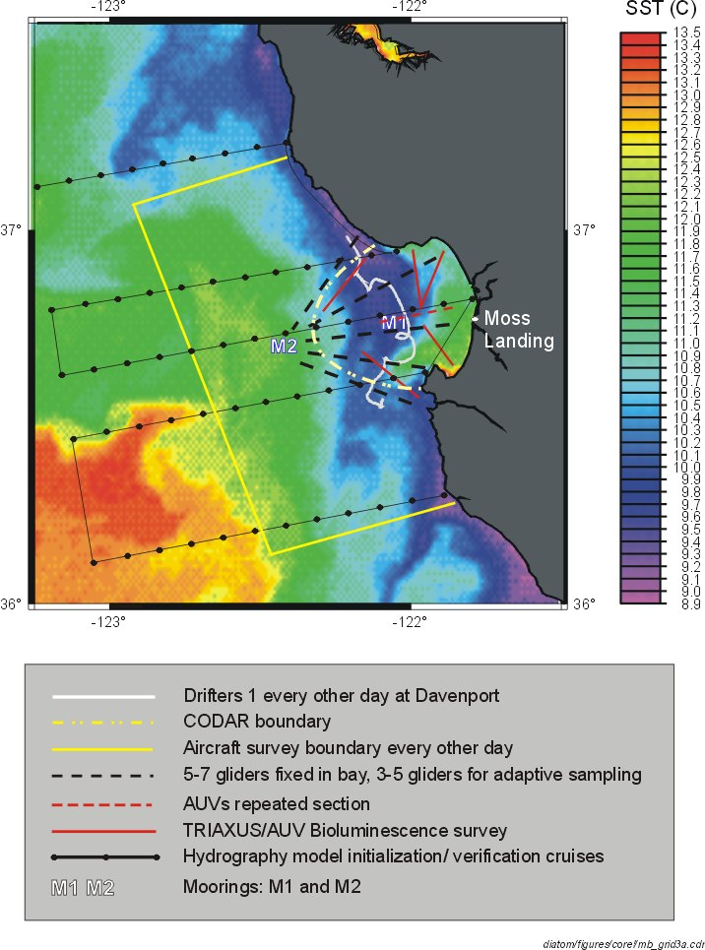

The AOSN deployment schedule is dictated by the availability of the Pt. Sur. Deployment of assets will be made according to the following 5 experiment blocks plus a shakedown period “Block 0”. Many assets are always available and not listed below. Schedules for other assets, such as aircraft, are still TBD and therefore not listed below. We are negotiating to have the RV John Martin available from 14 July to 7 Sept. with some restrictions.

Block 0: Mon. 14-July to Fri 1 Aug.
System Shakedown.
- RV John Martin available.
Block 1: Sat. 2 Aug. to Wed. 6 Aug.
Model Initialization and Start of Science Experiments:
- McMannus on RV Pt. Sur 2-6 Aug.
- 5 near shore gliders, 5 off shore gliders
Block 2: Thurs. 7 Aug. to Wed. 20 Aug.
Science Experiments and Model Skill Assessment:
- Haddock on RV Pt. Sur 9-18 Aug.
- 5 near shore gliders, 5 off shore gliders
Block 3: Thurs. 21 Aug. to Mon. 25 Aug.
Model Re-initialization, Science Experiments Continue:
- McMannus on RV Pt. Sur. 21-25 Aug.
- 5 near shore gliders, 5 off shore gliders
- 2 DORADO AUVs
Block 4: Tues. 26 Aug. to Tues. 2 Sept.
Science Experiments and Model Skill Assessment:
- RV Pt. Sur Not Available
- 5 near shore gliders, 5 off shore gliders
Block 5: Wed. 3 Sept. to Sun. 7 Sept.
Model Skill Assessment and Final Science Experiments
- McMannus on RV Pt. Sur 3-7 Sept.
- 5 near shore gliders, 5 off shore gliders

AOSN-II System Interconnectivity Diagram
Figure 2 maps out required AOSN-II system interconnectivity. Responsible scientists are identified where information is still required.

Model Nests
Model nests as referred to in Table 3 below have been specified based on input from the ROMS Modeling Team. This subsection details the ROMS nest definitions. It is hoped that the HOPS and ROMS nests can be chosen to be identical, as this will facilitate inter-model comparisons. Each model team will be responsible for creating their own nest definitions and for the means by which they will achieve inter-model skill assessment.

Figure 3: AOSN Nested Operations Areas as described by Yi Chao. Five areas are to be defined and described better in future revisions of this image. The central three nests are depicted in this image. The five nests are: Pacific Basin (P), U.S. West Coast (W), CA Coast (C), Monterey Bay and Outer Waters (M), and Science Operations Area (S). Figure courtesy of Yi Chao, Jet Propulsion Laboratory, Pasadena, CA.
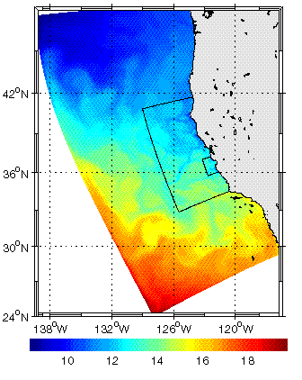
Five Nested Regions will be specified:
- Nest P: Pacific Basin
  - Domain
  - Spatial Resolution
    - 50 km horizontal
    - 20 vertical sigma layers.
- Nest W: U.S. West Coast
  - Domain
  - Resolution in Space and Time
  - Spatial Resolution
    - 15 km horizontal
    - 20 vertical sigma layers.
- Nest C: California Coast
  - Domain
  - Resolution in Space and Time
  - Spatial Resolution
    - 5 km horizontal
    - 20 vertical sigma layers.
- Nest M: Monterey Bay and Outer Waters
  - Domain
  - Resolution in Space and Time
  - Spatial Resolution
    - 1.5 km horizontal
    - 20 vertical sigma layers.
- Nest S: Science Operations Area (Experimental, High Risk, Not Promised)
  - Domain
  - Resolution in Space and Time
  - Spatial Resolution
    - 0.5 km horizontal
    - 20 vertical sigma layers.

Required Model Outputs and Additional Measurements
The required model outputs and additional science observations are listed in Table 3. This table is a works in progress. It is hoped that this table will be completed by the Modeling Teams and checked by the Ecosystem Team to ensure that the AOSN-II System will provide all the data required for the Science Experiments and for Model Skill Assessment. Figure 4 was provided by the ROMS Team. It has been retained here, as an example of some of the bio variables the Scientists would like to incorporate into the model.

Table 3: See Spreadsheet in Appendix A.

Figure 4: Structure and flow of the ten-compartment ecosystem used in ROMS as described by Yi Chao. Figure courtesy of Yi Chao, Jet Propulsion Laboratory, Pasadena, CA.

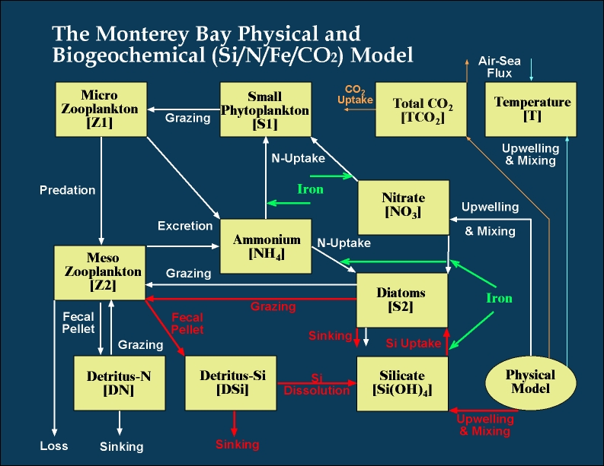

Features of Scientific Importance
The Predictive Systems must accurately model the features listed in Table 3. All features listed are to be predicted with:
- Lateral resolution ≤ 0.5 km
- Vertical resolution ≤ 1-5 m
- Temporal resolution ≤3 hours
- Parameter Values must at least have the correct sign. Improved accuracy and precision beyond this are both highly desirable with precision being more important than accuracy. The accuracy can be adjusted post-experiment as long as the precision is good.

Table 3: Features of Scientific Importance
Features
Upwelling Center Size
Upwelling Center Location
Upwelling Center Fontal Strength
Pycnocline Depth and Intensity
Modeling Team has requested that these Features of Scientific Importance get described in greater detail (Modeling Team to Help Ecosystem Team on next iteration of this document)
Modeling Team has requested that these Features of Scientific Importance include a description of the California current system.

Predictive Systems

HOPS
All issues related to HOPS, ESSEs, and HOPS skill assessment are TBD by Allan Robinson.

ROMS
All issues related to ROMS, and ROMS skill assessment are TBD by Yi Chao.

ICON
All issues related to ICON are TBD by Jeff Paduan.
The following ICON input was provided by Igor Shulman.

Model description.
The model orthogonal, curvilinear grid is presented in Fig. 5. The grid has a variable resolution in the horizontal, ranging from 1-4 km, with finer resolution around the Bay. The model has thirty vertical sigma levels. A three-dimensional, sigma-coordinate version of the Blumberg and Mellor (1987) hydrodynamic model is used. This three-dimensional, free surface model is based on the primitive equations for momentum, salt, and heat. It uses the turbulence closure sub-model developed by Mellor and Yamada, and the Smagorinsky formulation is used for horizontal mixing. Additional information on the model can be found in Blumberg and Mellor (1987).

Figure 5: ICON Model Grid. Figure courtesy of Igor Shulman, USM.
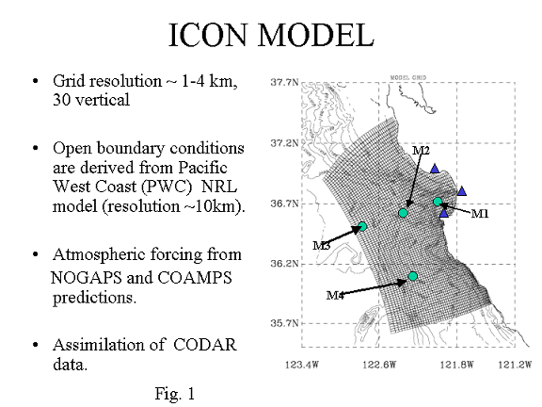

On the open boundaries, the ICON model is one-way coupled to a larger scale Pacific West Coast (PWC) model. There are two versions of PWC model. One version is also based on the Blumberg and Mellor, and another version is based on Navy Coastal Ocean Model (NCOM, Martin, 2000). Both versions have a horizontal resolution around 9-10 km and thirty vertical sigma levels. The PWC model domain extends seaward to 135W longitude, and from 30N to 49N in latitude. The PWC model has been run by Dr. Kindle’s group at NRL.

The ICON model has been forced with wind products from NOGAPS (Navy Operational Global Atmospheric Prediction System) and COAMPS (Navy Coupled Ocean and Atmospheric Mesoscale Prediction System) (Hodur, 1997) model predictions. The model has capabilities to assimilate SST and surface currents derived from CODAR predictions. The model was spun up from June of 1994 and was run until the end of September of 2000.

A large number of parallel runs were created for 1999 and 2000 that utilize a variety of atmospheric and boundary forcing functions. These runs are outlined in Table 4 and form the basis for most of the model-model and model-data comparisons analyzing the model predictions’ sensitivity to atmospheric forcing, open boundary conditions and grid resolution.

At the smaller scale, a fine-resolution frsICON sub-model has been set up within the ICON model domain for the purpose of high-resolution modeling of bioluminescence intensity. The frsICON model domain is presented in Fig. 6. The frsICON model grid has a variable resolution in the horizontal, with finer resolution (500-600m) around the upwelling front in the northern part of the Monterey Bay telescoping to coarser resolution (1.5 km) in the outer portion of the domain. On the open boundaries, the frsICON model is one-way coupled to the ICON model. The frsICON model has been forced with atmospheric products from 9km resolution COAMPS model predictions. Also, the frsICON model assimilates CODAR-derived surface currents.

Figure 6: ICON Grid for Fine Resolution ICON (frsICON). Figure courtesy of Igor Shulman, USM.
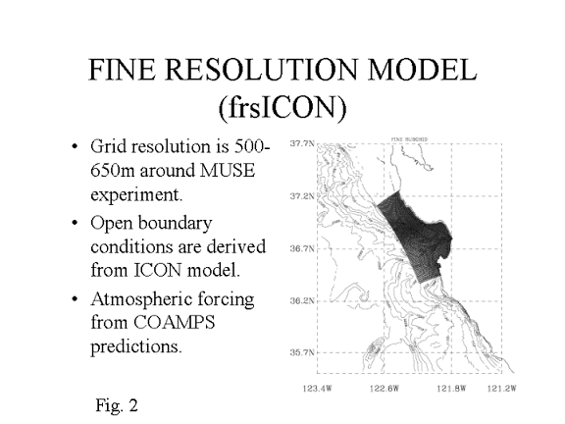

Representation of Upwelling Plume and the California Current system in the ICON model.
Analysis of the ICON model runs (Table 5) showed that high-resolution atmospheric forcing (COAMPS wind and heat fluxes) as well as accurate open boundary conditions (regional PWC is also forced with COAMPS) are critical for the model accuracy in representation of upwelling plumes and their interaction with the California Current system.

In run 7 (Table 5), the ICON model simulations reproduce upwelling filaments originating at Ano Nuevo and Pt. Sur areas. Upwelling filaments form and decay with realistic space and time scales. The model run reproduced a meandering front between the cooler upwelled water and the warmer water of the California Current, and narrow poleward-flowing the California Undercurrent.

With CODAR surface current data assimilation, the ICON model consistently tracks eddy-like features within the domain, and correlations between subsurface measured and model currents are improved.

AOSN II Participation.
In previous studies the ICON model was used in hindcast/nowcast mode. The model was never run in the real-time, forecast mode.

The following is needed in order to run the model in the real-time, forecast mode:
- Real-time, forecast of open boundary conditions from larger domain, regional model;
  - Traditionally, Dr. Kindle’s group at NRL provided outputs from PWC model for input on the ICON model open boundaries. At present, the PWC model is not set up to run in real-time, forecast mode. From personal communications with Dr. Kindle, the configuration of the PWC model for producing real-time forecasts is not research priority for the following 1-2 years. The PWC outputs can be provided in 1-2 months after the fact. For example, if AOSN II experiment will be conducted during July-August of 2003, the PWC outputs for July-August will be available around October of 2003.
- Real-time, forecast of surface high-resolution forcing (wind stresses and heat fluxes);
  - According to discussions during AOSN II Workshop, real-time forecasts of COAMPS wind and heat fluxes will be provided.
- 3-D fields of T, S, and velocity specified on some standard levels (like Levitus standard levels) and covering the domain larger than the ICON model domain (for the ICON model initialization). In contrary, the model should be spun up from Oct. 1 of 2000 to the start of the forecast.
  - Given that there is lack of open boundary conditions we will not be able to spin up the ICON model to the start of the forecast.
- Real-time data retrieval and exchange scripts and software for supplying open boundary conditions, atmospheric forcing, etc to the model input files.
  - This requires a programmer/technician with: working experience in writing scripts and software for real-time data retrieval and exchange; working knowledge of codes and scripts of PWC and ICON models. This is not funded. At present, we don’t have the particular person who can accomplish this task.

Based on above points a-d and research plans outlined in our proposal “Use of a Circulation Model to Enhance Predictability of Bioluminescence in the Coastal Ocean”, we consider the following feasible participation and support of the AOSN II experiment:
- Provide ICON model outputs to AOSN II group (see bullet in 2.2.1 section). Also, we are in a process of the model preparation for runs in 2001 and 2002. Model outputs from 2001-2002 runs will be provided as soon as these runs will be completed.
- Collaborate with adaptive and optimal sampling groups on testing their techniques with ICON model output data.
- Investigate outputs from ICON model to better estimate the space-time evolution of the upwelling plumes and their interaction with California Current System (major hypothesis proposed for scientific objectives of AOSN II).
- Collaborate with HOPS and ROMS groups on installation of the predictive system in the Monterey Bay area.
- Conduct hindcast/nowcast runs of the ICON model for time frame of the AOSN II experiment and compare model outputs with forecasts produced during the experiment.

In our proposal “Use of a Circulation Model to Enhance Predictability of Bioluminescence in the Coastal Ocean”, we proposed modeling activities, which will be undertaken in conjunction with the high-resolution bioluminescence observational program being conducted by Dr. Haddock in the Monterey Bay area. The objective of these modeling activities is the use of the circulation model for optimization of limited spatial and temporal bioluminescence (BL) sampling for maximum impact on short-term (2-3 days) BL forecasts. We will use ICON and frsICON models to study optimal positions for BL sections during various oceanographic seasons and various atmospheric conditions. We will conduct this research in collaboration with adaptive sampling groups involved into AOSN II experiment.

Model Intercomparison Table
To be prepared by Modeling Team

Adaptive Sampling
All issues related to Adaptive Sampling are TBD by Naomi Leonard.

Automated Survey Planning and Mission Planning
TBD

Adaptive Control of Observation Assets
TBD

Data Quality Control
Data QC will be the responsibility of the team who owns the asset unless the owner of the asset negotiates with MBARI to accept QC responsibility for the specific asset.

Operations
The need for an Operations Team is certain. The staffing of the Operations Team is still TBD.

Data Flow Issues
The Operations Team will be responsible for sorting through all remaining data flow issues not resolved by the other Teams. A quick cut at the steps involved in AOSN data flow are as follows:
- Observations are made by deployed assets and communicated to a server.
- Data is read, QC’d, and sent to next server
- Data is read, packaged for assimilation, and sent to next server.
- Data is read, assimilated into model/s.
- Model/s is run.
- Forecast data, error analysis, and data requests are forwarded to Adaptive Sampling
- Adaptive sampling generates survey plan and mission plan and sends info to operations
- Operations communicates mission plan to each asset
- Adaptive Control provides dynamic feedback control of assets while on mission.
- Data sent once again to QC to close the loop and start the next model cycle.
- Skill assessment is performed based on forecast data, previous detailed measurements, and current detailed measurements.

Data Management and Archiving and Database Access
- TBD, MBARI to take lead and organize discussions on this topic.

Coordination and Automation Software
- Multiple flavors required.
- Development not currently funded in most cases.

Teams

Ecosystem Team
Steve Haddock (Lead)
Francisco Chavez
Mark Moline
Jeff Paduan
Ken Johnson
James Case
Edie Widder
John Ryan
Christie Herren
Margaret McManus
Ron Tipper

Modeling Team
Allan Robinson (Lead, Lead for HOPS)
Yi Chao/Francisco Chavez (Lead for ROMS)
Jeff Paduan (Lead for ICON)
Igor Shulman
Pierre Lermusiaux
Craig Bishop
Dennis McGillicuddy
Naomi Leonard
Jerry Marsden

Adaptive Sampling Team
Naomi Leonard (Lead)
Jerry Marsden
Allan Robinson
Pierre Lermusiaux
Yi Chao
Jeff Paduan
Igor Shulman
Dave Fratantoni
Clancy Rowley
Ralf Bachmayer
Eddie Fiorelli
Joshua Graver
Pradeep Bhatta
Chad Coulliette
Francois Lekien
Shawn Shadden

Observation Asset Team
Dave Fratantoni (Lead)
Steve Ramp
Francisco Chavez
Steve Haddock
Hans Thomas

Data Quality Control Team
TBD (Lead)
TBD

Operations Team
Wayne Leslie? (Lead)
Hans Thomas
TBD

Executive Team
Jim Bellingham (Lead)
Craig Bishop
Paul Chandler
Francisco Chavez
Tom Curtin
James Eckman
Manny Fiadeiro
Dave Fratantoni
Steve Haddock
Ken Johnson
Naomi Leonard
Jerry Marsden
Jeff Paduan
Steve Ramp
Allan Robinson
Igor Shulman
Tom Swean
Ron Tipper

Appendix A

Table 3: AOSN Measurement and Model Requirements
Provided as separate MS Excel Document. The spreadsheet may be incorporated into this document at a later date.

