OBSERVATION PLAN FOR JULY-SEPTEMBER AOSN2 EXPERIMENT
Working objective:
To observe and understand the development and decay, associated frontal structures, bay flushing, air-sea coupling/exchange, biological consequences and relationship to the California Current System, of the cold-water plume that develops across the mouth of Monterey Bay in response to large and possibly small scale atmospheric forcing. Figure of SST and chlorophyll satellite images from August 16, 2000 included below. Additional documents: Excel spreadsheet (aosnIIschedule.xls) ship schedule.
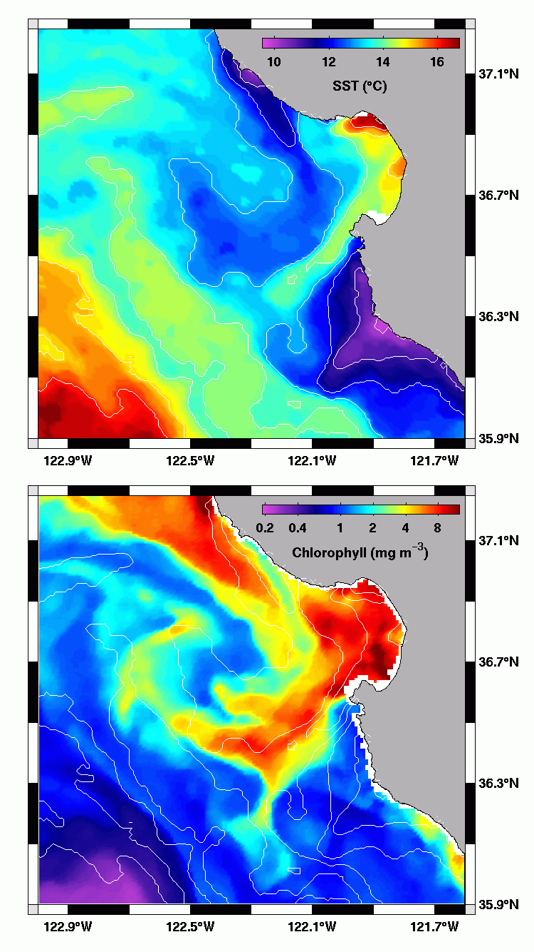

Deployments by Platform

R/V Pt Sur – Physical Oceanography Legs
Cruise Objectives: The Point Sur will conduct three surveys at the beginning, middle and end of the field experiment to provide semi-synoptic 3-D physical, chemical and biological fields to 1000m for model initialization and validation. See Figure for the current survey plan relative to the model domain. Will be adjusted.
Principal Investigator/Cruise Points of Contact – Margaret McManus (physics), Francisco Chavez (chemistry and biology)
Email – Margaret@emerald.ucsc.edu
Phone –
Mobilization Date – 8/1 (leg #1), 8/20 (leg #2), 9/2 (leg #3)
Cruise Dates – 8/2 to 8/6(leg #1), 8/21 to 8/25(leg #2), 9/3 to 9/7(leg #3)
Demob Date – 8/7 (leg #1), 8/26 (leg #2), 9/8 (leg #3)
Profiling Instrumentation – CTD Rosette w/ SBE11CTD, Bottle Samples
Profile Measurements | Vertical Resolution(m) | Max Profile Depth(m) | Instrument
C,T,Press | 0.5 | 6000 | SBE-3,SBE-4, SBE-11
PAR | 0.5 | 6000 | Biospherical PAR
Fluorometer | 0.5 | 6000 | Chelsea
Transmissometer | 0.5 | 6000 | Wetlabs
Fast repetition rate fluorometer | 0.5 | 200
 | 0.5
Nitrate Concentration | Water Samples taken at TBD depths
Chlorophyll | Water Samples taken at TBD depths
Dissolved Oxygen | Water Samples taken at TBD depths
Primary production | Water Samples taken at TBD depths

Underway Instrumentation – Surface C/T, Fluoro, 150kHz ADCP, Meteorological

Vertical Resolution(m) | Along-Track Profile Resolution(m) | Max Profile Depth(m) | Instrument
N/A | 100 | N/A | Surface CT
N/A | 100 | N/A | TBD Fluoro
N/A | 100 | N/A | MBARI pCO2 sensor
N/A | TBD | 300 | 150kHz ADCP
N/A |  |  | Ship met data

Cruise Track –

R/V Pt Sur – Bioluminescence Surveys
Cruise Objectives: The Point Sur will conduct night-time biolume surveys, and will perform daytime towfish surveys. The towfish will be equipped with BP, ISUS (possibly),C/T/D, fluoro. Underway sampling and profiling will also be performed
Principal Investigator/Cruise Point of Contact – Steve Haddock/John Ryan
Email – haddock@mbari.org
Phone – 831-775-1793
Mobilization Date – 8/8
Cruise Dates – 8/9 to 8/18
Demob Date – 8/19
Profiling Instrumentation – CTD Rosette w/ SBE11 CTD (see above), Bottle Samples, Schindler Traps

Towfish Instrumentation
Vertical Resolution(m) | Along-Track Profile Resolution(m) | Max Profile Depth(m) | Instrument
1 | 400 | 50 | CTD & pH
TBD | 400 | 50 | Fluorometer
1 | 400 | 50 | ISUS
1 | 400 | 50 | Gen3 BP

Cruise Track-TBD

Spray Gliders
Cruise Objectives: The main focus of the deep gliders is on California Current System dynamics. See figure for proposed 5 glider array.
Principal Investigator: Russ Davis
Email: rdavis@ucsd.edu
Phone: 858-534-4415
Mobilization/Deploy Date: 7/21 to 8/1
First Deployment: 7/25
Recovery/Demob – 9/3 to 9/8
Instrumentation Summary:
Platform | SIO Gliders 1-3(possibly 5)
Location/Tasking | Off-Shore Measurements
Max Water Depth/Max Profile Depth | 200-300m/500m
Profile Measurements | Vertical Resolution(m) | Along-Track Profile Resolution(m) | Max Profile Depth(m) | Instrument
C,T,Press | 5m@surface, 20m below 300m | 2300 | 750 | ?
PAR | Not Measured
OBS/Fluoro | 5m@surface, 20m below 300m | 2300 | 750 | OBS | fluoro
Nitrate Concentration | Not Measured
Biolume | Not Measured
Dissolved Oxygen | Not Measured
Currents & Acoustic Backscatter | Not Measured (Can be inferred from track)

Cruise Track –
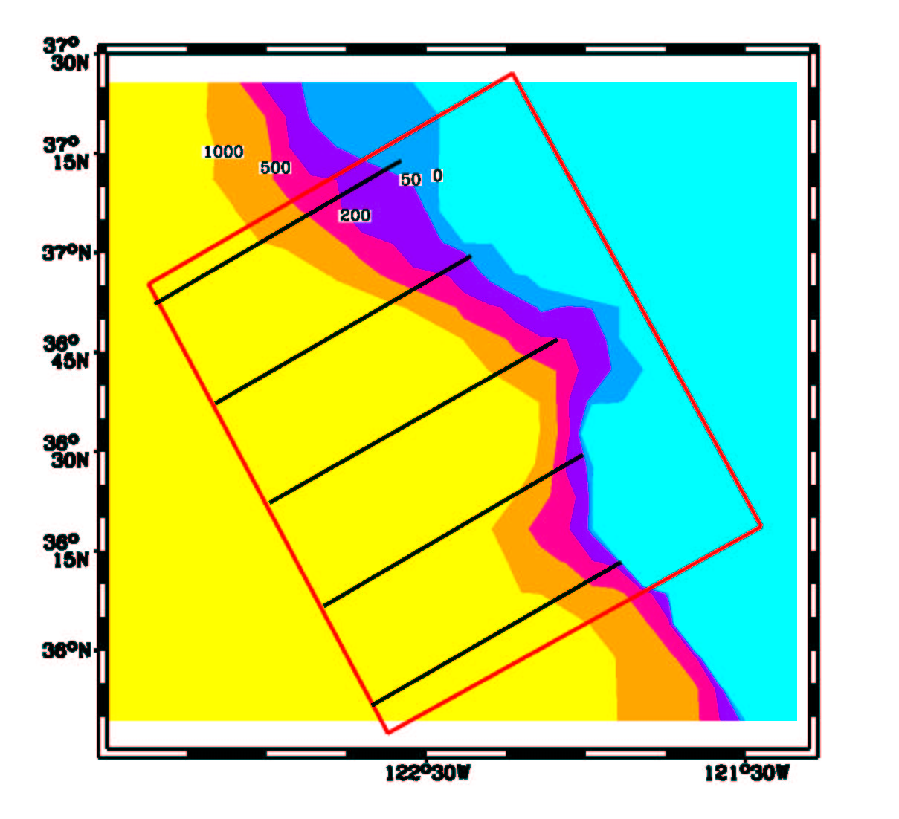

3) Shallow (Webb) gliders. Probably have 12 gliders with a maximum of 10 deployed at one time. The primary focus of the shallow gliders is on the cold water plume and associated structures. Four to five of the gliders dedicated to "fixed" grids (Task 1) and the other five to adaptive sampling (Task 2 and 3). See full document at http://people.deas.harvard.edu/~leslie/AOSNII/index.html. Chavez has suggested adding a 1e to get outflow from southern MB.
Principal Investigator/Cruise Point of Contact – David Fratantoni
Email – dfratantoni@whoi.edu
Phone – 508-289-2919
Mobilization/Deploy Dates – 7/14 to 8/1
Operational Dates – 8/14 to 9/3
Recovery Dates – 9/3 to 9/8

Max Water Depth/Max Profile Depth | 200-300m/200m
Profile Measurements | Vertical Resolution(m) | Along-Track Profile Resolution(m) | Max Profile Depth(m) | Instrument
C,T,Press | 0.5 | 800 | 200 | Glider CTD
PAR | TBD | 800 | 200 | Custom PAR
OBS/Fluoro | TBD | 800 | 200 | eco-bb2f
Nitrate Concentration | Not Measured
Biolume | Not Measured
Dissolved Oxygen | Not Measured
Currents & Acoustic Backscatter | Not Measured (Can be inferred from track)

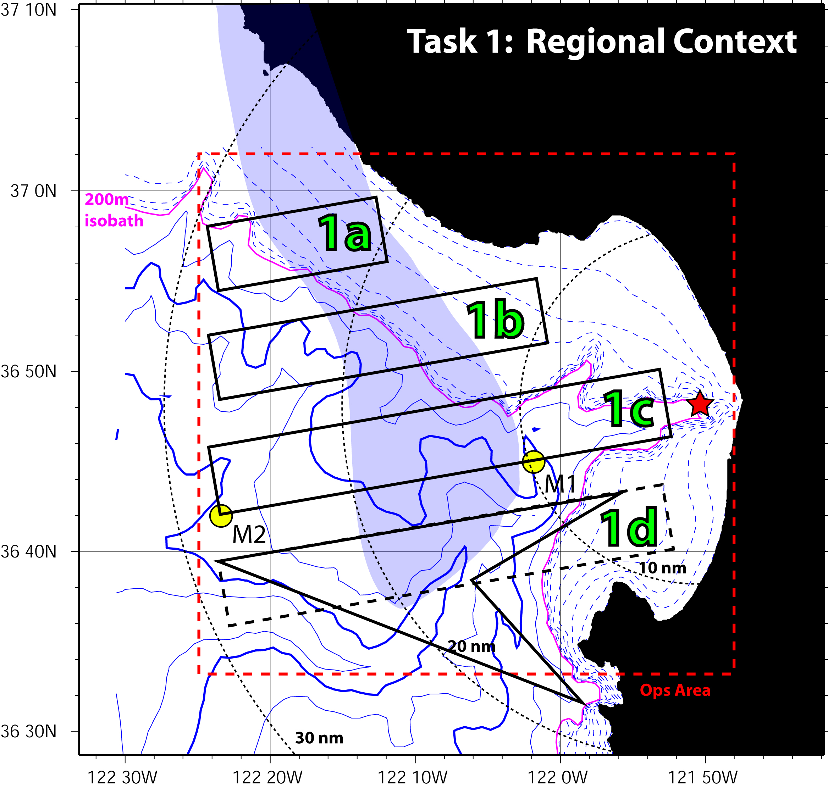

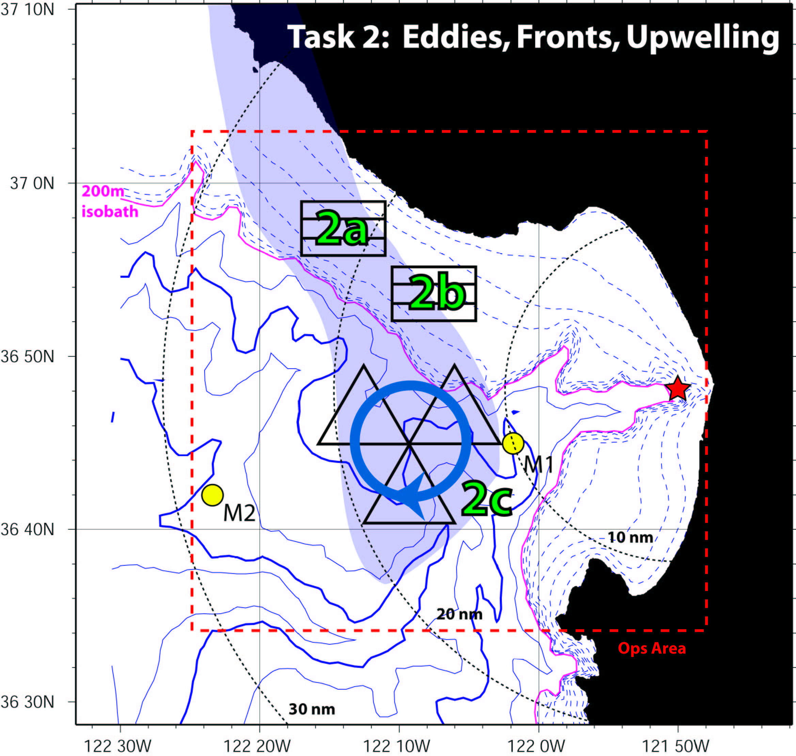

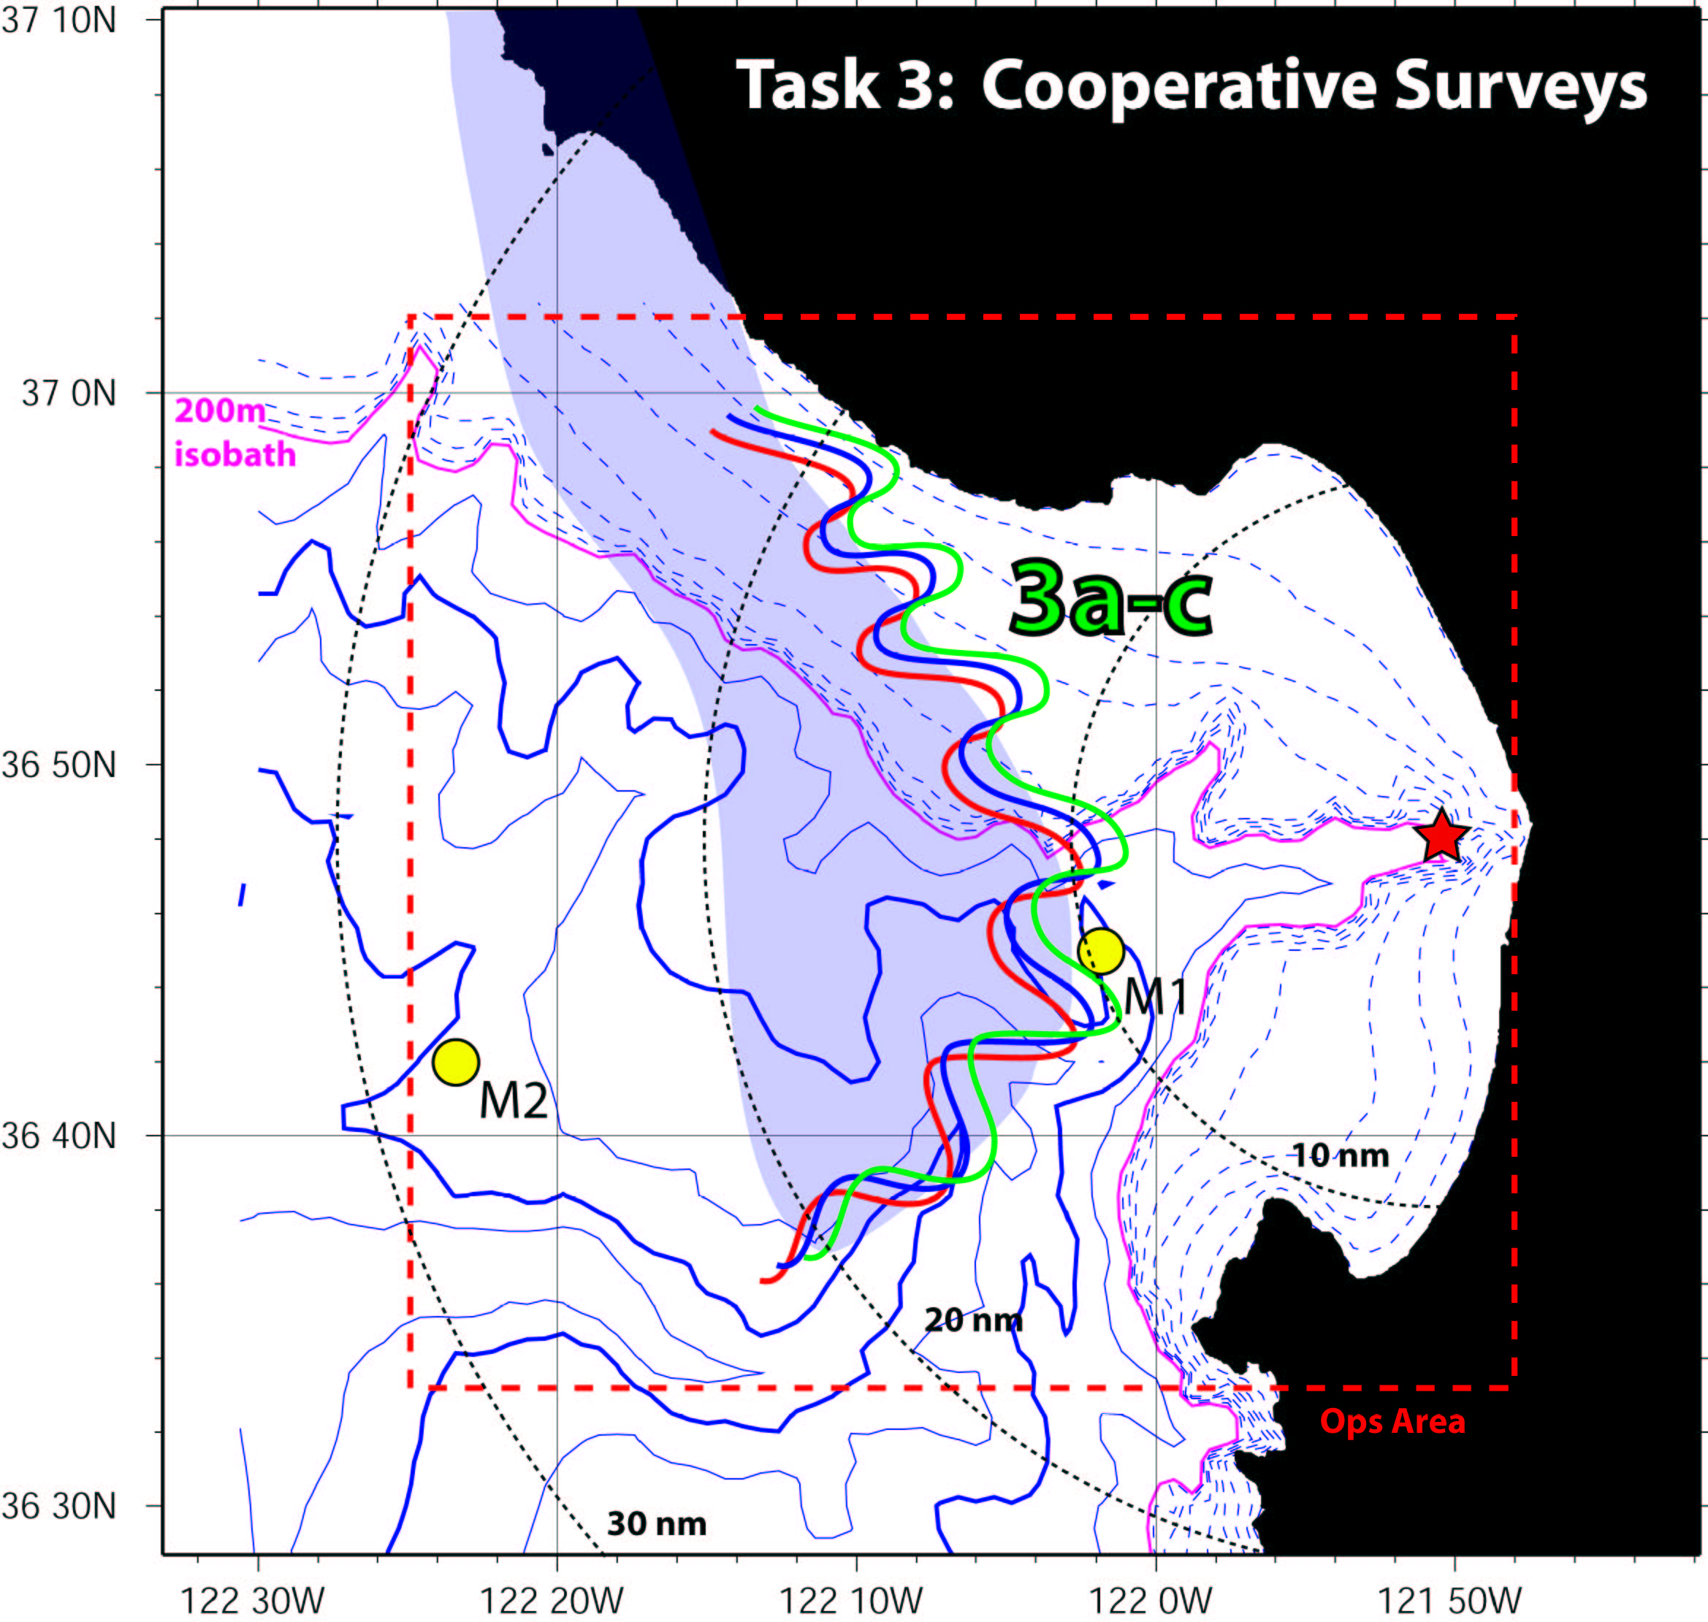

4) Dorado AUV. AUV surveys will be carried out with the Zephyr acting as the deployment vessel. Night surveys will be conducted in support of the Point sur bioluminescence cruise. Day surveys are part of a program that MBARI has just initiated to add AUV data to the regular time series sampling that has been carried out for 14 years. These started in April and there will be one every three weeks to August. Frequency will be increased in August. The surveys start halfway between C1 (Moss Landing) and M1, pass by the M1 mooring, to halfway between M1 and M2, and hence they cross the inshore front but may not always reach the offshore front (see Figure).
Platform | Dorado1
Location/Tasking | Spokes Transects
Max Water Depth/Max Profile Depth | >2000m/150m
Profile Measurements | Vertical Resolution(m) | Along-Track Profile Resolution(m) | Max Profile Depth(m) | Instrument
C,T,Press | 0.125 | 424 | 150 | C | T | D
PAR | Not Measured
OBS/Fluoro | 0.25 | 424 | 150 | HS2 | wet
Nitrate Concentration | 0.25 | 424 | 150 | ISUS
Biolume | 0.25 | 424 | 150 | BP
Dissolved Oxygen | 0.125 | 424 | 150 | Seabird
Currents & Acoustic Backscatter | 0.1 | 0.3 | 150 | 300kHz ADCP
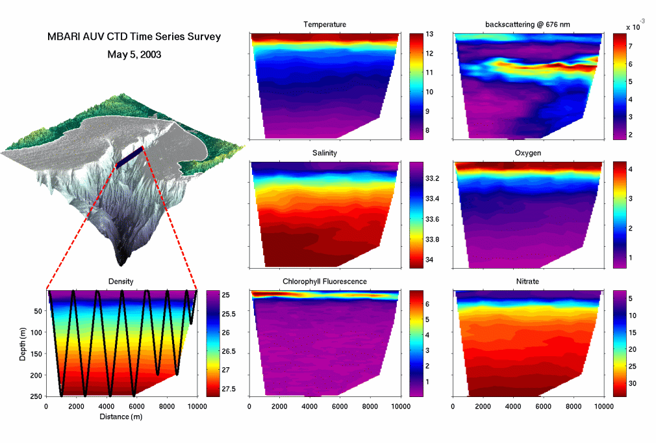
Principal Investigators: Steve Haddock/Francisco Chavez/John Ryan
Email: chfr@mbari.org
Phone: 831-775-1709
Mobilization/Deploy Date: ongoing (see Excel spreadsheet for ships)

5) NPS AUV1: AERIES. Vehicle will be used to demonstrate downloading ADCP data with an AUV. The vehicle will be launched from Monterey and swim to an ADCP deployed with an acoustic modem on the southern shelf. The two (Benthos) modems will establish communications and the vehicle will download the last few days of data. Vehicle will then steam back to Monterey and deliver data physically, or by surfacing along the way and experimenting with different data transmission techniques such as satellite, freewave, cell phone, etc. Will be done approximately every other day.
Principal Investigator: Tony Healy/Steve Ramp
Email: sramp@nps.navy.mil
Phone:

6) NPS AUV2: REMUS: Tony Healy coordinating with Mark Moline on the best way to use this vehicle. They have lots of transponders between them. Mark talking about going all the way across instead of out to M1 and back. The NPS vehicle could still take CTD/ADCP obs and the usual stuff.
Principal Investigator: Tony Healy/Steve Ramp
Email: sramp@nps.navy.mil
Phone:

7) San Luis Obispo Remus AUV. Transects from Santa Cruz to M1 mooring. Focus on bioluminescence. Need updated plans. Nightly runs starting on August 9th and ending on night of August 17th. Lauch from UCSC vessel Paragon.
Platform | Cal Poly REMUS
Location/Tasking | SPOKES Line South from Santa Cruz
Max Water Depth/Max Profile Depth | 1000m/150m
Profile Measurements | Vertical Resolution(m) | Along-Track Profile Resolution(m) | Max Profile Depth(m) | Instrument
C,T,Press | 0.125 | 424 | TBD | OS200 CTD
PAR | Not Measured
OBS/Fluoro | 0.25 | 424 | TBD | HS2 | wet
Nitrate Concentration | Not Measured
Biolume | 0.25 | 424 | TBD | BP
Dissolved Oxygen | Not Measured
Currents & Acoustic Backscatter | 0.1 | 0.3 | TBD | 1200kHz up/down ADCP
Principal Investigator: Mark Moline
Email: mmoline@calpoly.edu
Phone: (805) 756-2948

8) Floats. Two profiling floats to be deployed in the plume just offshore of M1. Profiles to 200 m, 10-12 hours at depth during day, 10-12 hours at surface during night. Intended to mimick zooplankton and understand retention mechanisms. Measure T, C and pressure.
Principal Investigators: Russ Davis/Francisco Chavez
Email: rdavis@ucsd.edu
Phone: 858-534-4415
Mobilization/Deploy Date: 7/21 to 8/1
First Deployment: 7/25
Recovery/Demob – 9/3 to 9/8

9) Drifters. Surface drifters equipped with C, T, pCO2 sensors and backscatter and fluorescence. Deployed one every other day in northern MB, expect to have maximum of three deployed at one time. Provide an element of time/advection in the plume. Deployment of clusters in the bay can be considered for CODAR validation.
Principal Investigator: Francisco Chavez
Email: chfr@mbari.org
Phone: 831-775-1709
Mobilization/Deploy Date: 7/21 to 8/1
First Deployment: 7/25
Recovery/Demob – 9/3 to 9/8

10) Moorings. M1, M2 S2. S2 is a current meter and sediment trap mooring close to M2. NPS ADCPs. Deploy two, one with a modem and one recording in the internal self-contained mode. The self-contained deployed on the northern shelf for model verification. The other will be on the south shelf somewhere convenient for the AUV download test. Another mooring with ADCP and vertical profiler to be deployed by John Ryan, MBARI on the 50m isobath.
Principal Investigator: Francisco Chavez\Steve Ramp\John Ryan
Email: chfr@mbari.org
Phone: 831-775-1709
Mobilization/Deploy Date: 7/21 to 8/1
First Deployment: 7/25
Recovery/Demob – 9/3 to 9/8
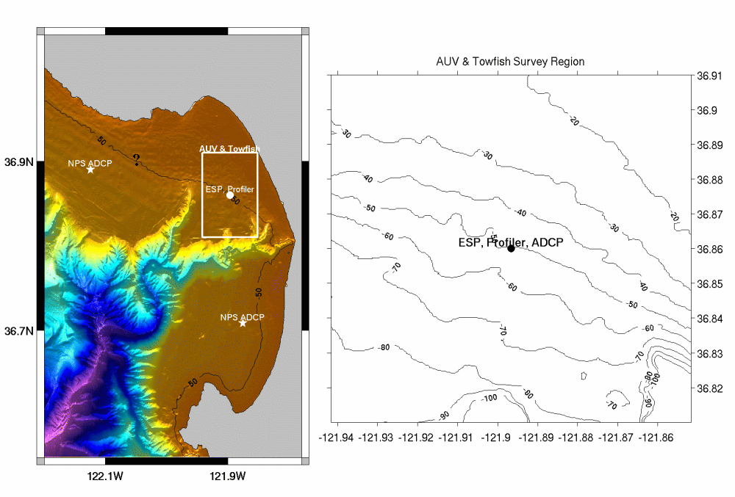

11) Aircraft. Surveys every other day. Latest maps can be found at http://www.oc.nps.navy.mil/~teanders. Alongshore coverage shortened from initial surveys. Synoptic coverage of plume area.
Principal Investigator: Steve Ramp/Jeff Paduan
Email: sramp@nps.navy.mil
Phone:
First Deployment: Ongoing
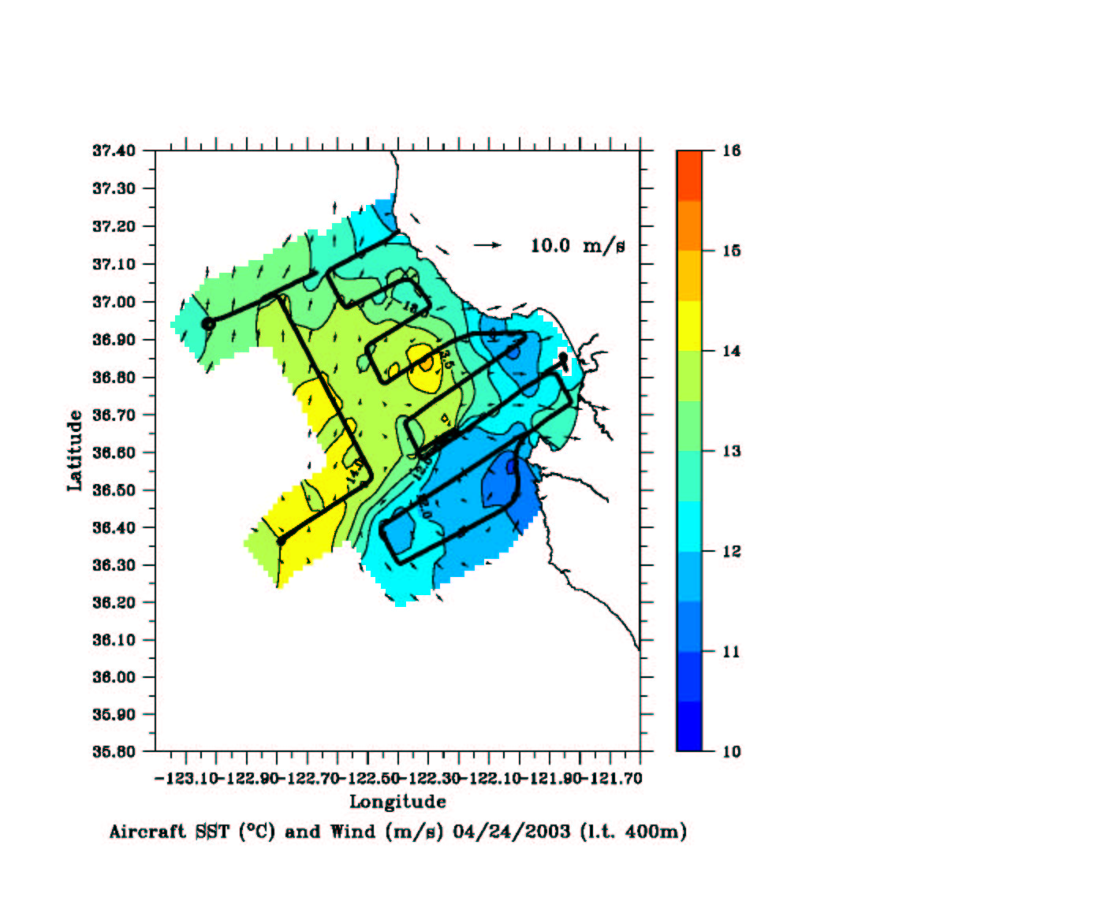
12) The Martin’s primary responsibility is deployment and recovery of gliders, floats and drifters. At times it will be used for model verification CTD surveys.
Principal Investigator: Hans Thomas
Email: hthomas@mbari.org
Phone: 831-775-1976
Mobilization/Deploy Date: 7/15 to 9/8

13) Biolumiscence team will use the Shana Rae before and after POINT SUR biolumiscence cruise for conducting of the biolum and physical fields, to give context to POINT SUR observations, and guidance to what "state" (i.e. relaxation/upwelling/transition) the system is in entering during the cruise. Tracks TBD.
Principal Investigator: Steve Haddock
Email: haddock@mbari.org
Phone: 831-775-1793
Mobilization/Deploy Date: 8/2-8/24

14) Biolumiscence team will use the Paragon in support of CalPoly Remus AUV. Tracks TBD.
Principal Investigator: Mark Moline
Email: mmoline@calpoly.edu
Phone: (805) 756-2948

15) AXBT surveys
Principal Investigator: Steve Ramp/Wayne Leslie
Email: sramp@nps.navy.mil
Phone:
First Deployment:
