Data-Based Objective Analysis
&
Qualitative and Quantitative Comparisons between Data and Models

RTOP members
(DRAFT, May 23, 2003)

Background

During the RTOP telecon on May 2, 2003, members feel a strong need to define the Skill Metrics for the 2003 August experiment. During the ET telecon on May 14, 2003, the group adapted Russ’s suggestion to produce data-based objective analysis maps during the August experiment.

The goal of this document is to satisfy these two requirements and initiate an evolving document so that RTOP and AOSN-II members can iterate and improve it in the coming weeks/months. The final document should define most, if not all, of the skill metrics and data-based objective analysis maps to be used by RTOP during the August experiment.

Please email your comments and suggestions to Yi.Chao@jpl.nasa.gov, who will keep tracking the most updated document.

PREDICTION GOAL. Provide skillful daily forecasts of physical and biological variables in the Monterey Bay region up to 5 days with longer experimental outlooks.
(Adopted from AOSN II System Goals and Performance Metrics, R. Davis, J. Bellingham, P. Chandler, F. Chavez, N. Leoanard, A. Robinson, revised 16 April 2003)

According to conversations with the COAMPS group (Rich Hodur), it is not realistic (both scientifically and computationally) to make COAMPS forecast for more than 3 days. Thus, our ocean model forecast should be confined to the 3-day forecast as well. Please let us know if you have strong objections.

Objective B1 (skill assessment). Demonstrate quantitatively accurate forecasts of Bay-scale patterns of temperature, salinity, velocity within an approximately 100 km by 100 km region between Pt. Ano Nuevo and Pt. Sur.

I. Data-based objective analysis

Main observations for comparison are
CODAR – U_{SURF}. Moorings & Vert. profiler – U, T, S profiles Pt. Sur surveys – T, S profiles Gliders – T & S profiles,$\int{U \text{dz}}$
AUVs – T,S at depth NPS Aircraft & NOAA Sat – SST
P3 AXBTs – T profiles ADCPs – post experiment U profiles

Based on the 2000 AOSN-II experiment, one can anticipate that we will produce the following data-based objective analysis maps on daily basis.

Figure I-1. CODAR surface current (available from NPS CODAR web site, Jeff Paduan or MBARI data server, Hans Thomas, needs to be confirmed???)

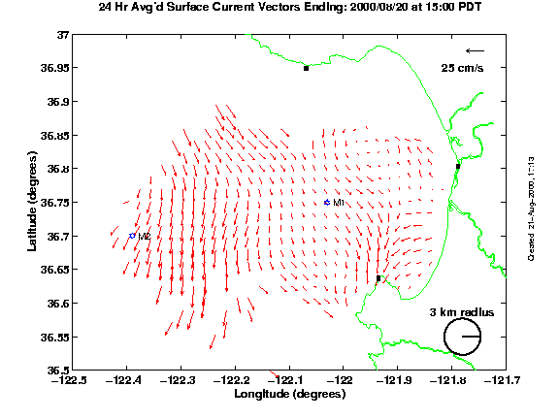

Figure I-2. T, S profiles (from Pt. Sur, AXBTs, mooring, gliders, available from MBARI server, Hans Thomas)

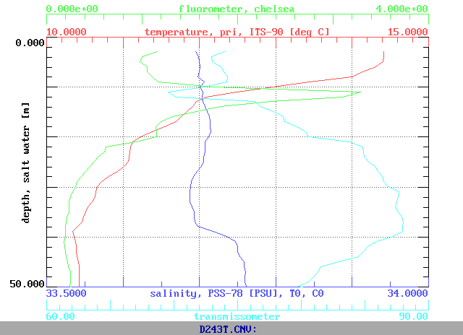

Figure I-3. AUV surveys (available from MBARI server, Hans Thomas)

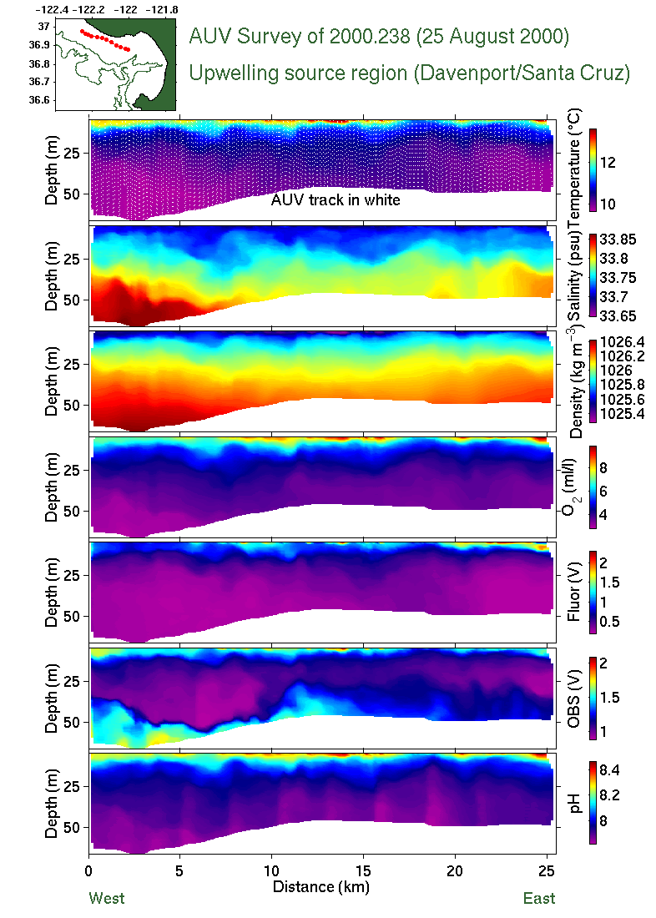

Figure I-4. ADCPs from NPS or Pt. Sur (available from NPS or MBARI server, Hans Thomas, needs to be confirmed???)

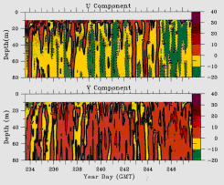

Figure I-5. NPS aircraft SST (raw data available from MBARI data server, Hans Thomas, and pictures available from NPS web site, Steve Ramp)

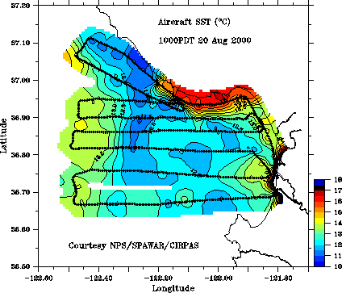

II. Qualitative comparisons between data and models

Metric: Carry out subjective retrospective comparisons of forecasts of a day with (a) subsequent now-casts for the same day and (b) trained-observer analyses of that day based on observations. The primary aim will be to develop general descriptions of the phenomena that are predictable and those that are not.

Approach: Based on the data-based objective analysis maps, one can simply compare them (via human eyes) with simulations by HOPS and ROMS.

III. Quantitative comparisons between data and models

Metric: Compare predictions and observations within the region of concern. RMS misfit of T, S, U_{H}, SST with expected sampling error on model’s scale and with observed variability over the region of interest and compare pattern correlation with sampling error in measuring it.

Approach: This metric will be satisfied by quantitatively comparing data and model simulations through various statistical methods.

Definition of model products: (assuming that the model is update daily)

1) Simulation: without assimilation of the last day’s data
2) Analysis: with assimilation of the last day’s data
3) Forecast (up to a lead time of 3 days): based on the model analysis and forced
with COAMPS forecasted wind, the model will perform forecast up to 3 days into
the future

Available observations and proposed model/data comparisons (figures & statistics)
- Vertical profiles of temperature (T) and salinity (S)
  - Moorings (M1, M2: fixed longitude/latitude)

Figure III-1: Depth profiles of temperature (or salinity). Symbols represent observations and solid line represents model analysis.
If there are N-member ensembles, the standard deviation of the N-member ensembles can be plotted as an envelope over the ensemble mean.

Over a period of several days (e.g., during an upwelling event), correlations and RMS differences can be computed at each depth, and results can be summarized in a table. One can compute the RMS difference using model simulation and analysis separately, and the improvement from the model simulation to the analysis will show the impact of the new data being assimilated into the system.

Table III-1. Correlations and RMS differences of temperature (or salinity) between the mooring data and the model simulation and analysis by HOPS (or ROMS) at M1 during the period of August 1-31 of 2003.
Depth (m) | Correlation |  | RMS Difference
0 | Simulation | Analysis | Simulation | Analysis
50
100
150
200

Figure III-2: Time series (up to 3 days into the future) of the model forecasts (can be a single line for a single model realization or a group of lines for N-member ensembles) at various depths. Observational data can be plotted (in red line) only to the present.
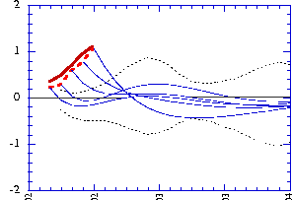
This plot will be updated with time when more data become available in the future. After 3 days, one can evaluate the skill of the last 3 days’ forecast and assess the skill of model analysis. The improvement from the forecast to analysis will show the impact of new data being assimilated into the model.

  - Pt. Sur Surveys (moving longitude/latitude provided daily)
  - Gliders (moving longitude/latitude provided daily)
  - P3 AXBTs (T only, moving longitude/latitude provided daily)

Figure III-3: Depth-distance plot of temperature (or salinity) from data (left panel), model analysis (right panel). One can also plot the difference between the two. A small plot of the spatial domain should be useful with the observational track being highlighted.

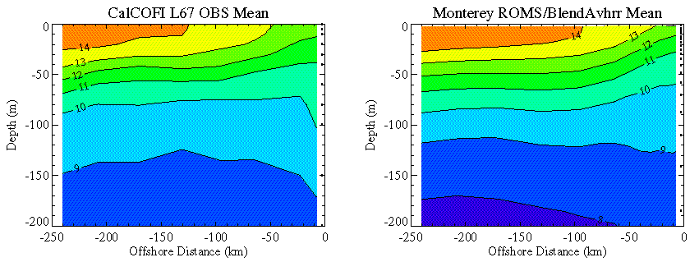
- Sea surface temperature (SST) from NPS aircraft

Figure III-4: Longitude-latitude map of SST from aircraft (left panel) and model (right panel).

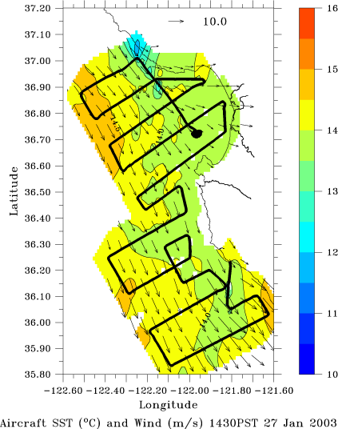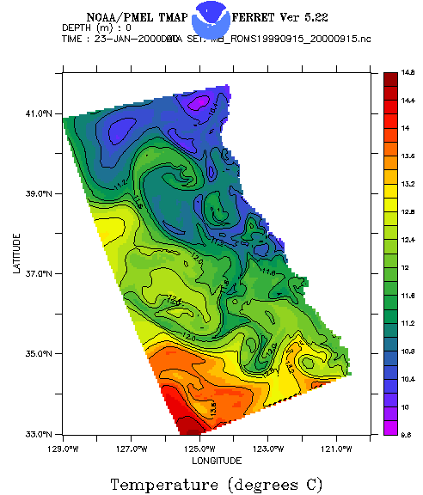

Figure III-5: Time series (over a period of 3 days) of the spatial correlation (left panel) and RMS difference (right panel, not the same scale and date). If there are N-member ensembles, an envelope of curves can be shown.

Note:

“Persistence” represents the model forecast that is initialized with analysis and forced with a fixed surface forcing, and will serve as a baseline for forecast and

“Hindcast” (or Forecast) refers to the model forecast initialized with analysis and forced with forecasted surface forcing.

“Retroactive” will repeat the forecast but assimilate all the new data sets being collected during this period.

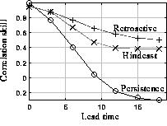
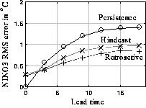

- Surface current from CODAR

Figure III-6. Longitude-latitude map of surface current from CODAR (left panel) and model (right panel). The spatial correlation and RMS difference can be computed.

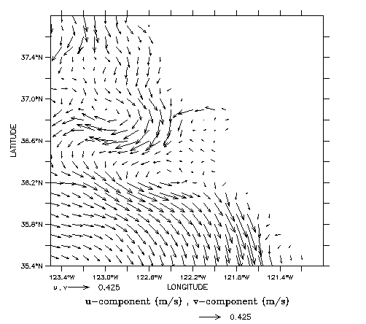

Figure III-7. Time series (over a period of 3 days) of the spatial correlation (left panel) and RMS difference (right panel). If there are N-member ensembles, an envelope of curves can be shown.
IV. Feature forecasts

Forecast position and characteristics of discovered small-scale dynamical features like eddies, fronts, and upwelling plumes.

IV.1 Tracking an upwelling event.

Starting from the onset of local upwelling-favorable (along-shore) winds, one should be able to track the evolution (life cycle) of one or more upwelling events during the 2003 August experiment.

Figure IV.1-1. Meridional component of the surface wind, showing the upwelling favorable wind starts from April 16 and lasts for about a week.

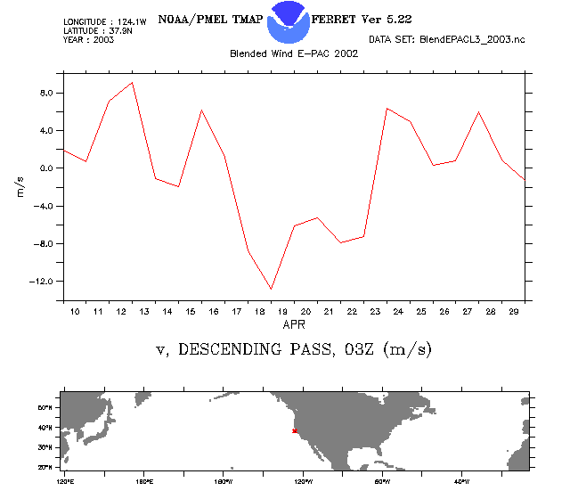

Using the aircraft SST (and satellite SST and color, if there are no much clouds during this period), one can validate the model-simulated upwelling event, e.g., the model-data misfits of positions, amplitude and evolution of the upwelling events.

Figure: IV.1-2. Longitude-latitude maps of ROMS-simulated nitrate (color) and surface current (white arrows), illustrating the oceanic response to the local wind forcing during April of 2003. The upwelling starts a few days later after the onset of the upwelling favorable wind, and lasts about 10 days before returning to normal conditions.

IV.2 Other synoptic events (suggestions are appreciated).

