Ecosystem Effects of Closed Areas in the Western Gulf of Maine

Lead Agency:  David Bergeron, Executive Director  Massachusetts Fishermen's Partnership  2 Blackburn Center  Gloucester, MA 01930  978-282-4847  dbergeron@mass-fish.org | Principal Investigator:  Prof. Allan R. Robinson  Harvard University  29 Oxford Street  Cambridge, MA 02138  617-495-2819  robinson@ deas.harvard.edu | Co- Principal Investigator:  Dr. Pierre Lermusiaux  Harvard University  29 Oxford Street  Cambridge, MA 02138  617-495-0378  pierrel@ deas.harvard.edu

Total budget request: $230,000

Abstract: This project seeks to study, characterize and predict physical transport processes in order to understand potential pathways of replenishment from closed areas to regions open to fishing in the Western Gulf of Maine (WGoM) with a focus on the transport of larvae of Atlantic Cod and American Lobster. The approach is based on a novel, reliable, observing, monitoring, modeling and predicting system (OMPS) for the WGoM, which will be applied to particle tracking and material dispersion. The major observing component of the OMPS will work with local fishing fleets. The data collected will be analyzed and assimilated into the physical-biological ocean models of the Harvard Ocean Prediction System (HOPS, e.g. Robinson, 1999) and used to predict the dispersal from the closed areas of the WGoM and Cashes Ledge closed areas. A special emphasis will be on potential influences on Massachusetts Bay. This project will draw on the considerable empirical knowledge and data of local fishermen and on extensive previous experience at Harvard University and National Marine Fisheries Service (NMFS) in the region and generally. We expect to demonstrate the utility of a sustainable fishing vessel based observing system to enhance regional ocean monitoring/modeling/predicting capabilities and the potential rewards of involving the knowledge base and seagoing resources of the commercial fishermen and their fleet in cooperative oceanographic/ecosystem-science/fisheries management studies. The main goals of the project relate directly to the utility of areal management and stock sustainability issues that are at the core of current fisheries management discussions.

TOPIC AREA PROPOSED RESEARCH ADDRESSES
This project responds to the Oceanographic and Meteorological Monitoring topic area by equipping and employing commercial fishing vessels as platforms for ocean monitoring, modeling and prediction, by providing data to interested users on weather, sea-state, and oceanographic and fishing conditions, and by providing synoptic coverage of large regions.

This project also responds to the Ecosystem Approaches to Fishing and Management topic area by providing data critical to the understanding and regulation of our regional marine environment, specifically with an eye towards linking the physical and biological compartments of the ocean to gain an enhanced comprehension of the sea and its inhabitants.

STATEMENT OF NEED OR RATIONALE
This project seeks to study, characterize and predict physical transport processes in order to understand potential pathways of replenishment from closed areas to regions open to fishing in the Western Gulf of Maine (WGoM) with a focus on the transport of larvae of Atlantic Cod and American Lobster. The approach is based on a novel, reliable, observing, monitoring, modeling and predicting system (OMPS) for the WGoM, which will be applied to particle tracking and material dispersion. The major observing component of the OMPS will work with local fishing fleets. The data collected will be analyzed and assimilated into the physical-biological ocean models of the Harvard Ocean Prediction System (HOPS, e.g. Robinson, 1999) and used to predict the dispersal from the closed areas of the WGoM and Cashes Ledge closed areas. A special emphasis will be on potential influences on Massachusetts Bay. This project will draw on the considerable empirical knowledge and data of local fishermen and on extensive previous experience at Harvard University and National Marine Fisheries Service (NMFS) in the region and generally. We expect to demonstrate the utility of a sustainable fishing vessel based observing system to enhance regional ocean monitoring/modeling/predicting capabilities and the potential rewards of involving the knowledge base and seagoing resources of the commercial fishermen and their fleet in cooperative oceanographic/ecosystem-science/fisheries management studies. The main goals of the project relate directly to the utility of areal management and stock sustainability issues that are at the core of current fisheries management discussions.

Our study is part of a broad research initiative, the “Fishermen's Initiative for Scientific Habitat & Ecosystem Research” (FISHER) that is being coordinated by the Massachusetts Fishermen’s Partnership (MFP) to establish a foundation for an ecological understanding of the dynamical WGoM ecosystem structure and function. The initiative focuses on ecosystem processes helping to ensure sustainable harvesting of some key species. The long-term scientific focus is on the understanding of the complex dynamics of the marine ecosystem in the WGoM. It has multiple vital socioeconomic impacts, including fisheries and coastal management.

The HOPS group is a recognized world leader in realistic regional nowcasting, forecasting, and hindcasting; and has done pioneering work in the assimilation of interdisciplinary data into coupled physical/biogeochemical/ ecosystem ocean models (Robinson and Lermusiaux, 2002). Assimilation of physical and biogeochemical ocean data into the HOPS interdisciplinary forecasting system will provide the environmental fields for the protected areas and the adjacent regions. By coupling these fields with plankton data collected in this project, an analysis can be undertaken to examine transport of eggs and larvae of Atlantic cod and larvae of American lobster. There is extensive and detailed knowledge of the circulation, variabilities, and transport of the western Gulf of Maine based both upon HOPS work and a comprehensive synthesis of other studies.

This proposal originated from a collaborative prioritization of research questions. A series of discussions with the fishermen were responsible for the focus of the project on cod and lobster larvae. Although information is rapidly accruing on the role of closed areas in the Gulf of Maine in terms of their increases in biomass (Murawski et al., 2000), far less is known in terms of their role as egg and/or larval source areas (Fogarty and Murawski, 2005). Storm and tidal processes have been identified as important forcing mechanisms on regional oceanic properties and ecosystem dynamics (e.g. lobsters), especially during stratified spring-to-fall ocean conditions and strong tidal forcing (e.g. spring tides about every 14 days).

MAJOR GOAL AND SPECIFIC OBJECTIVES

The main goal of this cooperative proposal is to study, characterize and predict physical transport processes with direct implications for understanding potential pathways of replenishment from closed areas to regions open to fishing in the WGoM. Specific objectives include:
- Demonstrate a novel, reliable, observing, monitoring, modeling and predicting system for the WGoM, with application to particle tracking and material dispersion, utilizing local fishing vessels.
- Better understand dynamical processes that affect circulation and transport in the WGoM, including aspects of storm response and tidal processes, with an emphasis on Massachusetts Bay.
- Enhance ongoing relevant biological studies by evaluating together physical data and plankton information relevant to assessing the closures as potential source areas.
- Draw on the considerable empirical knowledge and data of local fishermen.
- Foster strong trusting relationships between commercial fishermen and scientists.

TECHNICAL APPROACH
A complex mosaic of closed areas involving year round and seasonal fishery closures is now in place in the Gulf of Maine. The WGoM is an area of high concentration of cod and an investigation of the potential role of the closed areas in this region with respect to cod abundance and egg and larval dispersal is of direct and immediate interest to management of this valuable resource. No published information on concentrations of adult lobster or of lobster larvae in the vicinity of the WGoM closed areas is currently available. However, earlier work in the nearshore WGoM (Lawton et al., 1982) indicated relatively high concentrations of lobster larvae off of Manomet Point. It is reasonable to assume that lobster larvae could be located in the vicinity of the closed areas. Particle tracking models have been used to infer the origin of lobster larvae located off Georges and Browns Banks with probable source locations linked to Penobscot Bay, ME and off Cape Cod, MA (Harding et al., in press).

The main physical features and important physical-biological sub-regions and processes in the area of interest have been identified, based on two recent important HOPS experiments (Fig. 1) (LOOPS98 and ASCOT-01). Massachusetts Bay is a 100 by 50 km semi-enclosed embayment adjacent to the Gulf of Maine. The mean circulation is cyclonic around the Bay (Geyer et al., 1992; Signell et al., 1993). This mean flow from Cape Ann to Race Point is mostly driven by forcings from the Gulf of Maine coastal current and mean wind stress (Bogden et al., 1996; Brown, 1998). In seasons with ocean stratification, when the planned experiments will occur, the mesoscale variability is significant. Importantly, the wind forcing often changes direction, with autocorrelation times of the order of a day. Strong wind events have been found to alter the structures of the buoyancy flow, and circulation features were found to be more variable than previously described, involving possibly one, two or three branches of the Gulf of Maine coastal current and several gyres, vortices, jets and rim currents (Robinson and the LOOPS Group, 1999; Lermusiaux, 2001). The variability of the mesoscale circulation in Massachusetts Bay (Fig. 1) occurs on seasonal and weather driven scales. These, together with fluctuations in Gulf of Maine inflows, river discharges, (sub)-mesoscale internal dynamics, and external and internal tidal forcing drive a variety of coupled processes. Similarly, turbulent patches, small-scales, internal tides and waves just west of Stellwagen Bank have been observed to have a strong impact on biological variables. These processes still need to be studied and quantified. Storm and tidal event dynamics were chosen to initiate this research.

In order to establish a dependable data collection system using local commercial fishing vessels, a 1.5-year project will be undertaken. Eight fishing vessels (Table 1) will be outfitted with sensors for physical and biogeochemical variables. The data collected by the fishermen will be studied and assimilated into HOPS. The HOPS dynamical models will predict the ocean temperature, salinity and current fields, as well as biogeochemical fields (nitrate, ammonium, chlorophyll, plankton, detritus, etc.) and predict dispersal pathways of spawning products of cod and lobster released in the closed areas. A subset of the fishing vessels will be equipped with plankton nets to sample eggs and larvae.

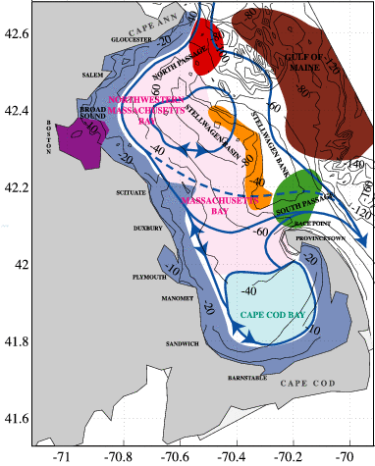
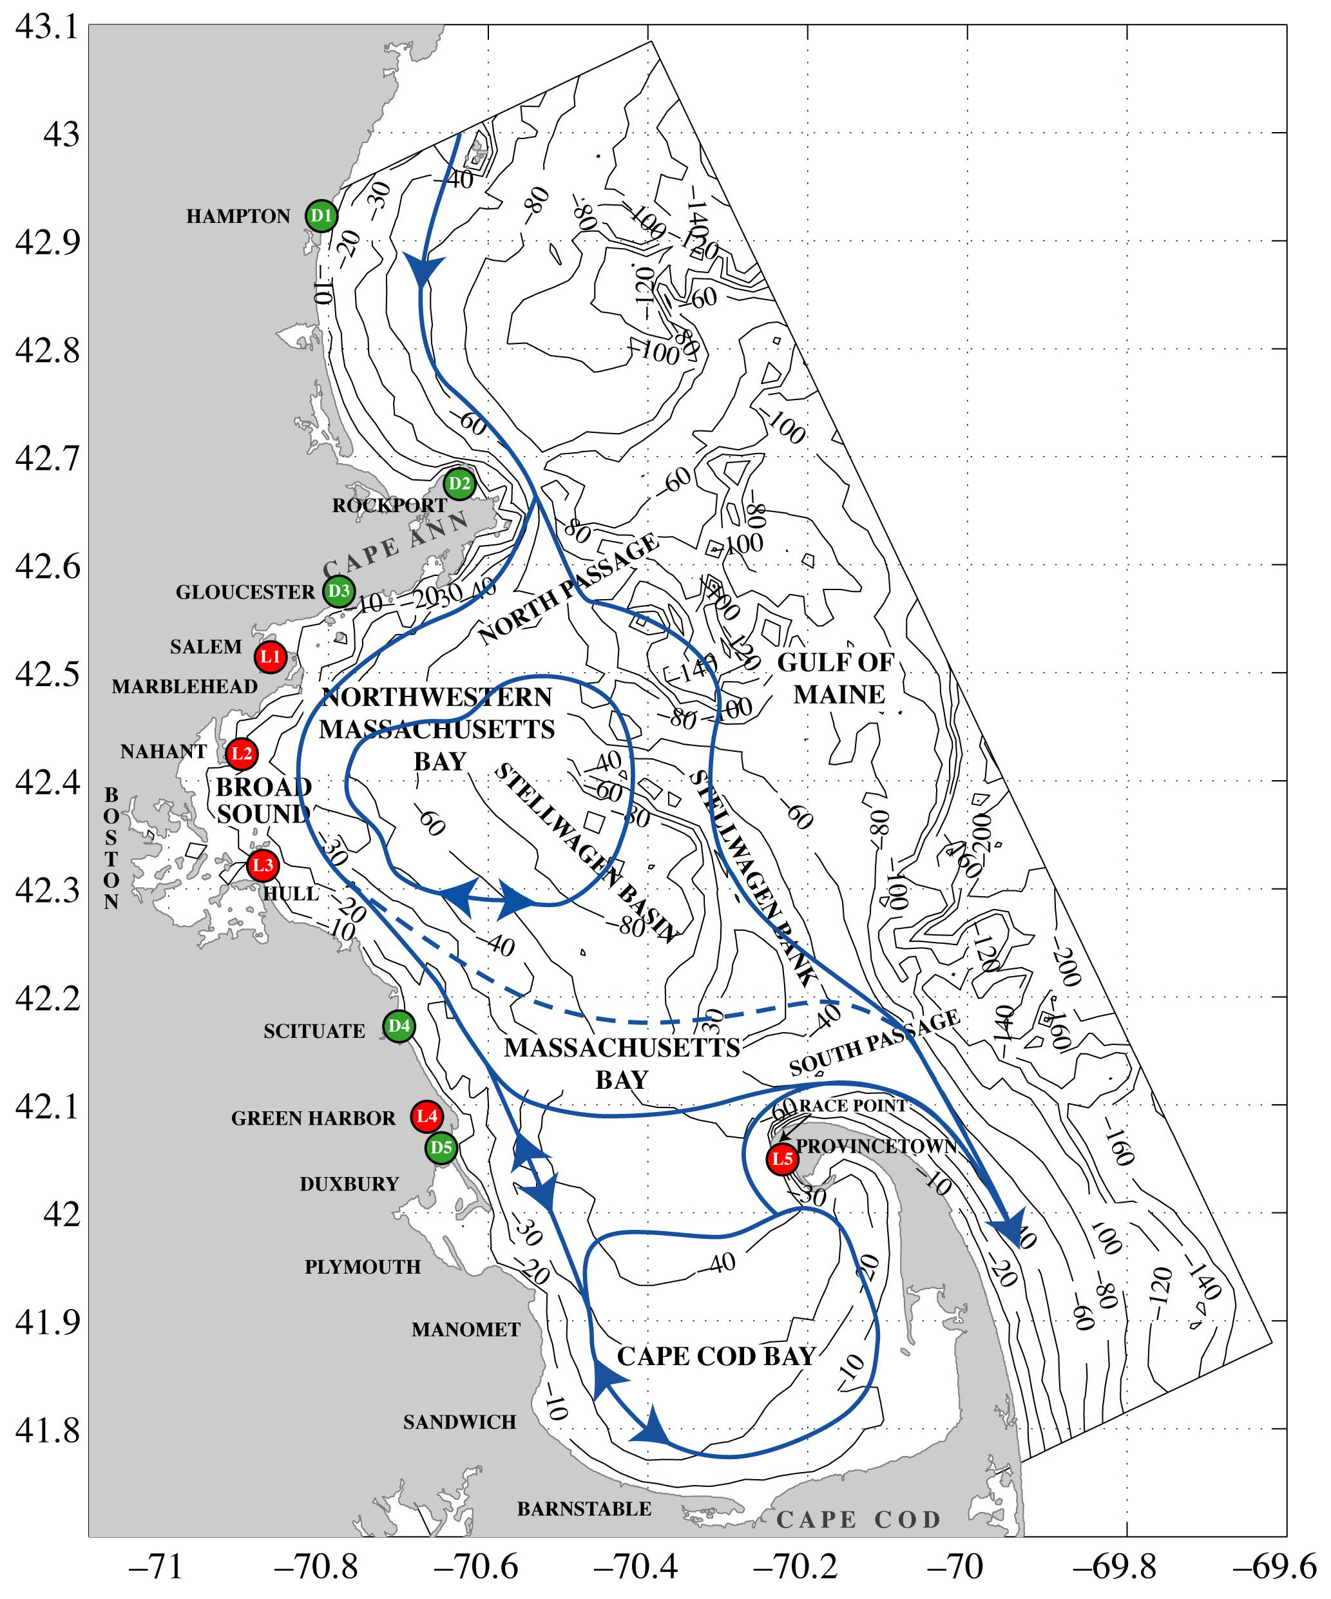
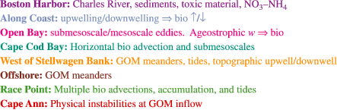
Our project aims to start on January 1, 2007 and end on June 30, 2008. The intensive sampling and prediction period will be February-September 2007 to encompass the spawning seasons of cod and lobster. Either January or February 2007 will be testing months, taking into account fishing regulations. Sampling for cod eggs and larvae will be concentrated in the principal period of occurrence, February-April. Lobster larvae will be sampled during June-August. Prior to that, workshops among scientists and fishermen will be held, and the modeling and observing system will be set-up. After the intensive period, the ocean and model data will be analyzed and results reported.
Figure Plate. Mass. Bay buoyancy circulation overlaid on: Fig. 1 (left): Physical-biogeochemical regions, Fig. 2 (right): Ports of fishing vessels

Participating vessels are from ports along the coast of Massachusetts (Fig. 2), providing good coverage (e.g. mesoscale, 5 to 10km resolution) of the WGoM. These vessels have been divided into 2 classes, “Lobster”, i.e. more coastal vessels, and “Trawler”, i.e. more open-ocean vessels. The sensors will be shared among fishermen and consist of 2 to 4 standard CTDs and mini-sensors mounted on fishing-gear. The data collected will include temperature, salinity, and fluorescence (a proxy for chlorophyll). The sampling will be divided into dedicated sampling (predetermined stations) and opportunistic sampling (stations of opportunity). Dedicated sampling will occur about once or twice a week, with sampling frequency being mainly a function of expected storm events. During the opportunistic sampling, fishing patterns will set the sampling patterns. However, to favor some repetitive (time-series like) observations, a small set of about 10 stations will be recommended. Ideally, data will be collected hourly, though four data recordings per day would be a minimum to be useful. Fishermen will be compensated at a daily rate for dedicated research days and at a per sample rate for data collected on opportunistic days. When study tidal events, research will take place closer to shore and to the western side of Stellwagen Bank. Tidal modeling activities will be carried-out in collaboration with A. Warn-Varnas of NRL-SSC (Warn-Varnas, et al., 2003). Priority tidal research days will include high and low tides, and full and new moon cycles.

Table 1: Chartered Commercial Fishing Vessels
Captain | Vessel Name | Length/  Width | Steaming Speed | Engine (hp) | Gear Type | Homeport
David Goethal | Ellen Diane | 44’/15’ | 9k | 360hp | Trawler | Hampton, NH,
Joe Francis | Nauset | 61’/19’ | 8k | 400hp | Trawler | Provincetown, MA
Paul Vitale | Angela and Rose | 45’/15’ | 8k | 350hp | Trawler | Gloucester, MA
Jim Keding | Zachary Nicholas | 45’/14’ | 8k | 300hp | Trawler | Plymouth, MA
Bill Mahoney | Marilyn M | 32’/12’ | 15k | 210hp | Lobster | Nahant, MA
Bob Marcella | AnnMarie | 42’/15’ | 12k | 355hp | Lobster | Hull, MA
Phil Michaud | Susan C III | 42’/14’ | 10k | 285hp | Lobster/  Trawler | Provincetown, MA
John Haviland | Emily Rose | 42’/15’ | 12k | 375hp | Lobster | Green Harbor, MA

HOPS will be utilized for the physical-biological ocean forecasting. It consists of data analysis and assimilation schemes (Lermusiaux, et al., 2002), feature models (Gangopadhyay, et al., 2002; Gangopadhyay and Robinson, 2002), and coupled interdisciplinary (physical, acoustical, optical, biogeochemical) dynamical models. It is a generic system that can be used for fundamental process studies, realistic nowcasting, forecasting, and hindcasting, and applied to any region of the world ocean. Operational physical forecasts have been carried out for over two decades. Coupled physical-acoustical (Robinson and Lermusiaux, 2003) and physical-biogeochemical (Besiktepe, et al., 2003) real-time data assimilation and dynamical studies have also been carried out. The ability to accurately forecast Lagrangian particle paths with HOPS (Lermusiaux, 2001) has been demonstrated in real applications (see e.g.,
http://people.deas.harvard.edu/~robinson/Staccato/staccato.html and http://people.deas.harvard.edu/~robinson/EA990/EA990.html ).

Plankton sampling will be conducted by using a systematic grid design covering the closed areas and adjacent areas in the vicinity of the closed areas to provide initial conditions for setting the particle-tracking simulations to determine dispersal patterns.

For the complete bibliography of this planning letter, please see http://people.deas.harvard.edu/~robinson/PAPERS/nec_planning_letter_refs_mfp_hu.pdf .

IDENTIFICATION AND BRIEF DESCRIPTIONS OF KEY PARTICIPANTS
The MFP is an umbrella organization of 18 commercial fishing associations representing all gear and geographic sectors of the Massachusetts fishing industry. The organization was created to promote common interests and economic viability of commercial fishermen and fishing families. Olivia Free, Collaborative Research Coordinator, has developed and managed numerous restoration and research projects ranging from salmon habitat restoration to selective gear development to species studies. For the past three years, she has coordinated cooperative projects in New England and has worked with commercial fishermen to develop and implement these endeavors.

Prof. Allan R. Robinson is the Gordon McKay Research Professor of Geophysical Fluid Dynamics at Harvard University. His contributions include the dynamics and modeling of ocean currents, and the influence of physical processes on biological dynamics in the ocean. He is recognized as one of the pioneer and leading experts in modern ocean prediction and has contributed significantly to techniques for the assimilation of multiscale and interdisciplinary data into ocean-forecasting models.

Dr. Pierre Lermusiaux obtained an Ir./B. in Eng. from Liege University in 1992 and a Ph.D. in Engineering Sciences from Harvard in 1997, where he is a Research Associate in the Division of Engineering and Applied Sciences. He has held Fulbright Foundation Fellowships, was awarded the Wallace Prize at Harvard in 1993, and presented the Ogilvie Young Investigator Lecture in Ocean Engineering at MIT in 1998. His research interests include physical and physical-biogeochemical-acoustical ocean dynamics.

Dr. James J. McCarthy is Alexander Agassiz Professor of Biological Oceanography and Head Tutor for degrees in Environmental Science and Public Policy at Harvard University. He recently completed a two-decade term as the Director of Harvard University's Museum of Comparative Zoology. His research interests relate to the regulation of plankton productivity in the sea, in particular the cycling of nitrogen in planktonic ecosystems. He was the founding editor of Global Biogeochemical Cycles.

Dr. Michael J. Fogarty is a Senior Scientist at the Northeast Fisheries Science Center, Woods Hole, MA. He holds adjunct appointments at the Woods Hole Oceanographic Institution, Univ. of Rhode Island, Univ. of Massachusetts and Univ. of Maryland. He has served on many national and international panels and committees including the Scientific Steering Committee of the U.S. GLOBEC program that he chaired from 1997-2002, and Global Ocean Observation System (GOOS) Steering Committee, and Coastal Observations Panel of GOOS. His current responsibilities include serving as Program Director for Ecosystem-Based Management at the Northeast Fisheries Science Center. His research interests center on the ecosystem effects of fishing and the role of climate change in marine ecosystem dynamics.

IDENTIFICATION OF END USERS
The end users of this project’s findings maps are numerous. Federal and state regulators, the New England Fishery Management Council, Governor Romney’s on-going implementation of recommendations from the Massachusetts Ocean Management Task Force, academic researchers, governmental researchers, student researchers, the commercial fishing industry, the recreational fishing industry, and the general public will benefit from this effort to characterize and predict physical transport processes with direct implications for understanding pathways of replenishment from closed areas to regions open to fishing in the WGoM.

ANTICIPATED PERMIT REQUIREMENTS
Because research will be conducted in closed areas in the Gulf of Maine, a permit to do so will need to be obtained from the National Marine Fisheries Service. Dr. Fogarty at the Northeast Fisheries Science Center will assist MFP staff in securing all requisite permits necessary to undertake this research. Participating fishermen will use Days-At-Sea only on opportunistic sampling days and will land their catch using standard fishing gear which will not result in an increase of by-catch mortality. On dedicated research days, the fishermen will not use Days-At-Sea and will not catch or land any fish since cod ends will not be attached to the trawl nets. These nets will be deployed only to take measurements. The use of CTDs and plankton nets will also not result in by-catch mortality.

BUDGET ESTIMATE AND JUSTIFICATION
For the period January 1, 2007 - June 30, 2008, we request funding support of $230,000 towards a total project budget of $470,000. The $230,000 budget will be distributed as follows:

Vessels/fishermen sampling rates $100,000 Industry
Vessels/fishermen instruments $30,000 Industry
MFP $40,000 Industry
Total Industry: $170,000

HU $60,000 Science
Total Grant Request: $230,000

In-Kind (HOPS System) $240,000 Science
Total Project Budget: $470,000

Vessels/fishermen Instruments and Sensors
We have contacted and received quotes from more than 15 companies on sensors that could be utilized for this project. Based on the information currently collected, we plan to purchase:
  - 2 to 3 CTD systems
  - About 8 mini-sensors
  - 2 to 3 Laptops for use aboard vessels so as to record and transfer the ocean data to shore
  - plankton nets to sample eggs and larvae

We are currently in the process of selecting CTD options. For opportunistic sampling, the DST CTD of staroddi appears to be the best solution (about $1,000 each for less than 10 sensors, $700-800 for more than 10). In addition, several of the fishermen have already used these sensors. Workshops will be held to familiarize the fishermen with the equipment, including installations on the vessels.

Vessels/fishermen sampling rates
The rate for dedicated sampling days is budgeted at $1,000 to $1,500 per vessel for a 10h day, with the total amount being a function of vessel size and instrumentations. Considering other costs, for the physical proposal, this allows for about 30 to 40 dedicated days, i.e. 3 to 4 dedicated days per vessel/fishermen. For a sustained 5 months period, this means about 2 dedicated trips per week. We are working on computing rates for opportunistic sampling that are advantageous to both fishermen and the research project. Flat rates will likely be used for ``pure'' opportunistic sampling (for mini-sensors, it mostly involve downloading the data). Special incentives can be given for the 10 or so preferred stations. Active fishing periods will favor opportunistic sampling while low or no-fishing periods will favor dedicated trips.

MFP
The MFP will oversee the grant, organize and manage the participation of the fishing fleet, and ensure proper dissemination of results and deliverables to end-user partners. Olivia Free will manage the participation of the fishing vessels including logistics, administration, and troubleshooting of issues as they arise. In addition, she will coordinate both a kick-off meeting to ensure that participants understand their roles and a final meeting at the conclusion of the project to debrief and solicit feedback on project processes and results. She will also assist with the coordination of training fishermen to use the necessary scientific equipment for this project. Lastly, she will assist with the preparation of progress and final reports, will help coordinate site visits by project monitors as needed, and will create a project tab on the MFP website to present timely project findings and results.

HU Sampling, Modeling and Predicting
The HU team will be responsible for carrying out the real-time forecasting. Allan Robinson and Pierre Lermusiaux will lead and coordinate the scientific research, including the real-time scientific forecasting. Costs budgeted represent support for the Harvard team (Patrick Haley, Wayne Leslie, John Nevins) in executing the research. Importantly, the actual cost for the ocean prediction and data assimilation is about 5 times as much as budgeted. James McCarthy will lead and coordinate the planktonic sampling and analysis. The HU effort is leveraged on other funds.

