Non-linear Optimization of Autonomous Undersea Vehicle Sampling Strategies for Oceanographic Data-Assimilation

Kevin D. Heaney and Philip Abbot
Ocean Acoustical Services and Instrumentation Systems, Inc., 5 Militia Dr., Lexington, MA 02421

Glen Gawarkiewicz and Timothy F. Duda
Woods Hole Oceanographic Institution, Woods Hole MA 02543

Pierre F.J. Lermusiaux
Division of Engineering and Applied Sciences, Harvard University, Pierce Hall, 29 Oxford St., Cambridge MA, 02138

Abstract – The problem of optimally deploying a suite of sensors to estimate the oceanographic environment is addressed. Automous Undersea Vehicles (AUVs) provide the opportunity to remotely sample the oceanography and acoustics of a region. Two AUVs were outfitted for physical oceanographic and acoustic propagation sensors and were deployed for a week off the coast of New Jersey in the Middle Atlantic Bight. An optimal way to estimate (nowcast) and predict (forecast) the ocean environemnt is to assimilate measurements from dynamic and uncertain regions into a dynamical ocean model. In order to determine the sensor deployment strategy which optimally samples the regions of uncertainty, a Genetic Algorithm (GA) approach is presented. The scalar cost function is defined as a weighted combination of a sensor suite’s sampling of the ocean variability, ocean dynamics, transmission loss sensitivity, model uncertainty (and others). A numerical example with 3 Gliders, 2 powered AUVs, and 3 moorings is presented to illustrate the optimization approach in the complex shelfbreak region south of New England.
I. INTRODUCTION
The problem of accurately predicting the ocean temperature and salinity fields for use by sonar performance prediction algorithms is addressed [1,REF1]. Current meso-scale oceanographic models have incorporated much of the relevant physics so that if initial and boundary conditions are known well, these models can provide useful predictions of the ocean tempearture, salinity and velocity fields. Recent developments in data-assimilation (Optimal Interpolation, extended Kalman Filtering and error subspace methods) have shown that models can predict the ocean state better with the inclusion of field data, and the use of models can improve mapped fields generated from measured data.

The challenge to this situation is cost. Working in the ocean is expensive and technically challenging. Methodologies that determine ideal ways to measure the ocean with the fewest wisely placed sensors are needed. An integrated optimization-assimilation-modeling system is being developed to perform optimal (cost-effective) ocean sampling and ocean prediction. The system involves the combination of three sub-systems or algorithms: 1.) An ocean model with data-assimilation capabilities (in our case the Harvard Ocean Prediction System [1, REF2, REF3, 2] (HOPS), with the Error Subspace Statistical Estimation algorithm [3, REF4] (ESSE)); 2.) An ensemble of measurement platforms (i.e. moorings, gliders, powered Autonomous Undersea Vehicles) and 3.) A non-linear constrained global optimization algorithm which determines the optimal placement of these sensors. In this paper, we present the measurement subsystems and the non-linear constrained global optimization sub-system.

The optimization approach is an application of the Genetic Algorithm (GA)[4]. The GA algorithm solves complex global optimization (minimization in our case) problems by generating a population of individuals (possible solutions) and within each successive population of individuals (iteration) choosing the survivors based upon the value of the complex cost-function surface. Mutation and cross-over, as well as other analogies to natural selection, are implemented to prevent the solution leading to a local minimum. The implementation of the GA solution requires a model for the search parameter space and the definition of a cost-function to be minimized. The parameter space will involve a vector for each platform defining it’s search geometry. Examples of vector values for a sensor deployment are initial position (lat/lon), initial direction, range of sample path, and number and direction of turns. Once a sensor deployment scheme is defined (an individual in the GA nomenclature) the cost function is evaluated using the values from the oceanographic model which this particular deployment of sensors would sample. The cost-function is evaluated for this individual, and then the GA generates another set of individual search laydowns based upon these results. In order to define the global cost function for the GA to optimize, a set of individual scalar cost function candidates have been developed.

The outline of this paper is as follows. In Section II, new features of the measurement system are presented, along with their successful deployment results for the summer of 2005 off New Jersey. Next, we use measurements and a fully data-assimilated model from the ONR Shelfbreak PRIMER Experiment [5] as the test-bench for the new methods we develop in Section III. This includes a description of the ocean model runs that were used for optimization. In Section IV the Genetic Algorithm optimization for multiple sensor deployment is presented and applied to these data-driven model runs. Section V is the conclusion, where specific plans for the future testing of this algorithm are discussed.

II. OCEANOGRAPHIC AND ACOUSTIC MEASUREMENT SYSTEMS
Recent advances in AUV development have provided the opportunity to adaptively sample the volume of the ocean [e.g. REF5]. The assimilation of this data (in addition to standard satellite measurements, moorings and Conductivity/Temperature/Density (CTD) casts) into ocean models has been demonstrated to provide improved accuracy of ocean models. With a combined goal of ocean forecast accuracy and acoustic propagation modeling accuracy, a suite of remote sensors are being developed. We now present two of these sensors and results from a recent cruise. The first is a Physical Oceanographic Sampling Remote Environment Monitoring UnitS Autonomous Underwater Vehicles (REMUS), which is a powered AUV outfitted with temperature, salinity, pressure, Acoustic Doppler Current Profiler (ADCP) and chlorophyl measurements. The second is a smaller powered vehicle called the OASIS Mobile Acoustic System (OMAS) which travels over a prescribed track and radiates a mid-frequency (900 Hz), low-power acoustic pulse every second. The OMAS can be combined with autonomous recording vehicles (Sonobuoys, or an acoustic array mounted to a REMUS or an AUV glider – both of which are under development) to remotely measure acoustic propagation for assimilation into either ocean prediction models, or Navy Sonar Performance prediction models [add REF here].

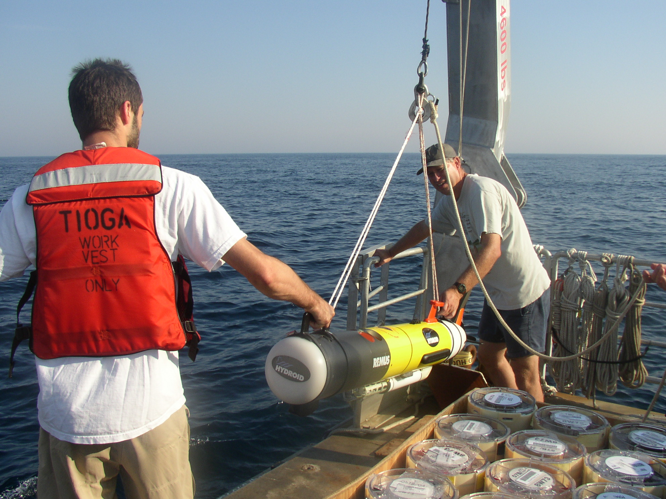
Figure 1. Deployment of the Woods Hole Oceanographic Institution Physical Oceanography REMUS Vehicle during the AWACS Pilot Cruise, July 2005.

The AWACS (Autonomous Wide Aperture Cluster for Surveillance) pilot cruise on the Woods Hole Oceanographic Institution (WHOI) RV Tioga from July 19 to 25, 2005, was designed to meet several goals. The first and main longer-term objective was to evaluate combined REMUS/OMAS operations to study oceanographic processes and Transmission Loss (TL) range dependence and uncertainty. The REMUS was newly augmented with both an Inertial Navigation system as well as an Iridium Satellite Communications system. Second, we planned to deploy 3 Tidbit (temperature only) moorings at the 70 m, 80 m, and 150 m isobaths to obtain information on temporal variability of the temperature field near the shelfbreak. Third, we planned to carry-out Conductivity-Temperature-Depth (CTD) sections when time permitted to supplement the REMUS sections. Finally, we wished to evaluate the utility of using the RV Tioga, a small coastal vessel, for short surveys at the shelfbreak.

The OMAS TL System operations were completely successful, with all Sonobuoys recovered and tracks run on four of the five days, two of which were concurrent with REMUS transects. Thus, we demonstrated the capability to sample both the ocean and acoustic fields concurrently, and in the future these data will be used with AWACS data assimilation methods to reduce uncertainty in the ocean and acoustic fields and to develop effective adaptive sampling strategies. The REMUS was operated on three days, obtaining a 30 km, 15 km, and 6 km transect along the 80 m isobath. Two of the three Tidbit moorings were recovered. The lost mooring was at the 70 m isobath. In addition, Rutgers University was actively cooperating with glider surveys and Coastal Ocean Dynamics Applications Radar / Advanced Very High Resolution Radiometer (CODAR/AVHRR) [6] data collection.

REMUS Operations

The REMUS vehicle successfully did a 30 km alongshelf transect on July 21 (Fig. 2). The section showed considerable variability in temperature and salinity along the line. The REMUS undulated between the surface and 80 m quite well despite the strong currents. The alongshelf variability was dominated by an offshore directed filament of shelf water in the southwest portion of the transect (left half of sections in Figure 2), and an onshore directed intrusion of slope water in the northeastern half of the section. The shelf filament had lower soundspeeds than the slope intrusion, with the largest alongshelf gradients in soundspeed occurring at a depth of 20 m. On July 24, we did a 50 km cross-shelf CTD section. The foot of the front was not fully resolved as there was still a warm, saline layer near the bottom at the most shoreward station at the 60 m isobath. The cross-shelf position of the front was generally shoreward of the climatological mean. In addition, a fairly strong pycnocline salinity maximum intrusion was observed in the REMUS, glider, and CTD sections, which will be examined in the future.

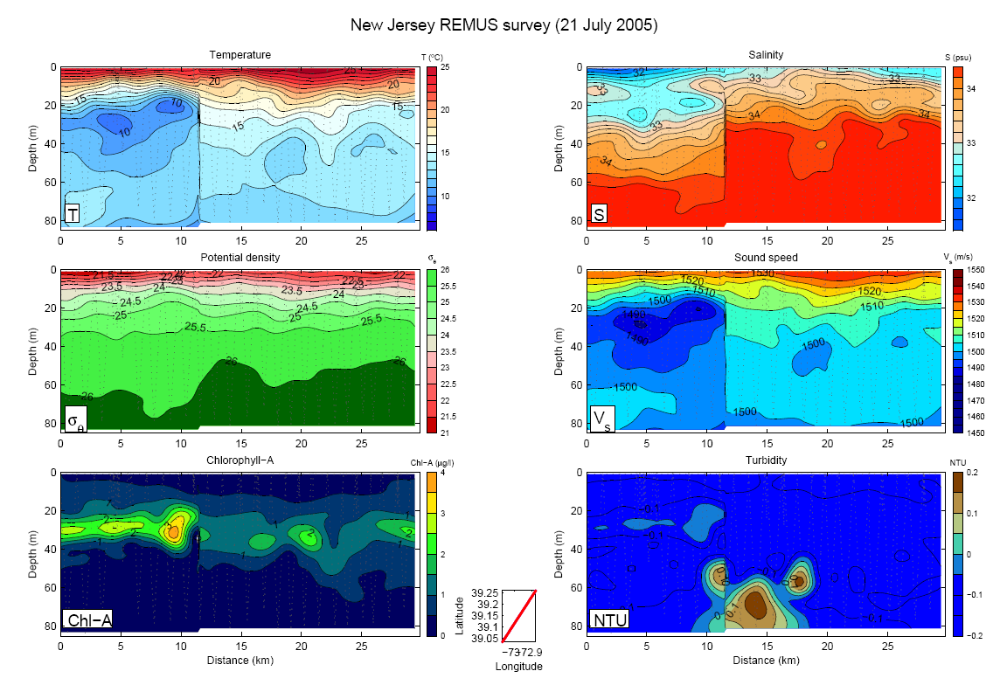
Figure 2. Measured Oceanographic Fields from a 30 km alongshelf REMUS section at the 80 m isobath near the shelfbreak off New Jersey. Figure provided by A. Shcherbina.

- OMAS TL System/Acoustic Operations

Extensive TL data were collected using various sonobuoy receivers (DIirectional Frequency And Ranging (DIFAR) and omni, [add REF here]) for propagation in the northeast and southwest directions along the 80 m isobath. FINEX tended to occur earlier than planned due to the loss of natural light for buoy recovery and we obtained about 50% of the acoustic data (i.e. the OMAS pinged once per minute and was programmed to operate for over 8hrs while we acquired for about 4 hrs).
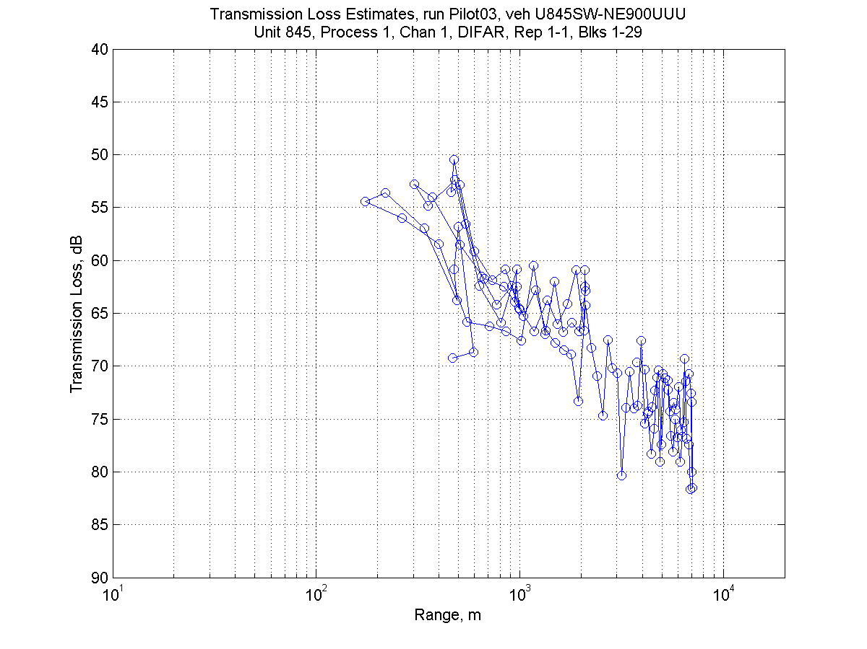
Figure 3. Measured Transmission Loss from OMAS to a sonobuoy for 4 different runs.

Figs 3 show some preliminary results from Run 3, a 7 km TL track run. Prior to launch, the OMAS run geometry was programmed for speed, depth and track. For Run 3, the speed and depth were set to 5 kts and 30 m respectively and the track was
programmed for a 2.5 x 0.5 km box, followed by an 8 x 0.5 km box. Both of these boxes were aligned with the local isobaths (NE to SW). DIFAR and omni sonobuoys were launched prior to each run and were attached to the GPS equipped spar buoy. Both receivers were set to deploy at 27 m depth and their acoustic signals were received with a 4 channel sonobouy receiver located aboard the RV. These signals were digitized, recorded and processed via two onboard laptops. The processing system determined range from the travel time of each received ping, and bearing from the DIFAR.

Using REMUS measurements from the previous day that showed a sound speed minimum at 30 m depth and therefore a potential for minimum TL if the source/receiver were deployed at this depth, we changed the OMAS depth from 55 m to 30 m for Run 3, as a preliminary attempt at data-driven adaptive sampling. The measured TL was reduced by a few dB relative to the deeper depths and the optimal depth for OMAS operation to minimize tranmission loss was likely achieved.

III. MODEL PROBLEM DEFINITION

A. Ocean Environment

In this paper, a data-driven model of the ocean in the Middle Atlantic Bight region (shelfbreak south of New England) will be used to illustrate the new optimal adaptive sampling approach. This is a region of high oceanographic variability that has been studied by US oceanographers and ocean acousticians for the past 15 years [add REFs here]. The shelfbreak is located 100 km offshore of the coast and interactions of the shelf-break front, Gulf Stream meanders and wind-driven response to storms create a complicated but interesting environment. The bathymetry for the region is shown in Figure 4a.
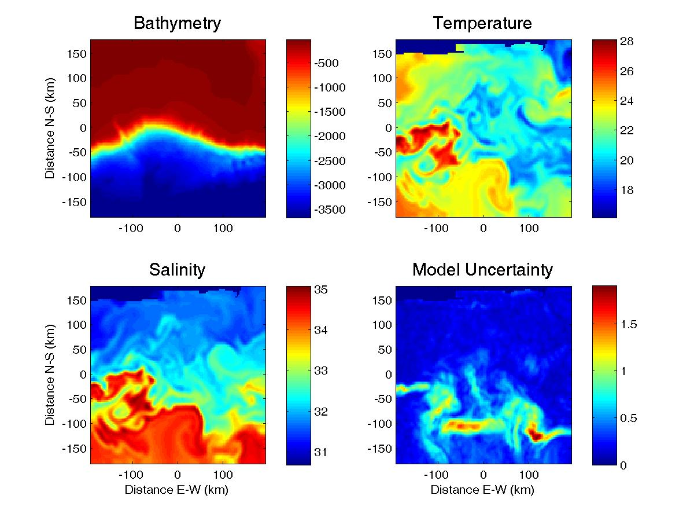

Figure 4. Illustration of the HOPS-ESSE simulations with assimilation of data from the ONR Shelfbreak PRIMER Experiment. Shown are the bathymetry (m) and horizontal snapshots of the surface temperature (ºC) and salinity (PSU) on day 30 and of the uncertainty of the surface temperature (ºC) on day 15.

Using measured environmental data (temperature, salinity and density) from the Shelfbreak PRIMER experiment from July, 2006, a 30 day simulation of the shelfbreak south of New England was generated using the Harvard Ocean Prediction System (HOPS) along with data assimilation via the Error Subspace Statistical Estimation (ESSE) algorithm. A significant amount of measured data went into this model forecast, including a week of SeaSoar high-resolution sampling which resolved the fields in terms of both the spatial and temporal correlation scales [5]. The resulting surface temperature and salinity fields (for day 30) are shown in Fig. 4 (upper right and lower left panels). The remnants of a slope eddy are visible in the surface temperature and salinity maps (at y=-50 km N/S, x=-100 km E/W). The surface expression of the shelfbreak front is visible as the high temperature/salinity gradient line at 0 km N/S in the western half of the model domain. In the eastern half, the shelfbreak front extends much further offshore, up to 100 km seaward relative to the western portion of the model domain. To illustrate the HOPS-ESSE estimate of ocean field uncertainties, the standard deviation of the surface temperatures of the ensemble of model simulations on day 15 is shown in the lower right panel of Fig. 4. On the shelf, the surface temperature uncertainty is around .2 to .4 ºC. Uncertainties are largest (above 1 ºC) around the surface expression of the shelbreak front and its eddies, from about y=0 to -100km, with a band of localized uncertainty near y=-100 km N/S, where the shelfbreak front extends far offshore. Such complex, time and depth dependent ocean fields (temperature, salinity, velocity) and their uncertainties will be used in the estimation of an optimal sampling strategy in the next section.
IV. GENETIC ALGORITHM OPTIMIZATION
To demonstrate the use of the non-linear optimization algorithm in the pre-planning stage, a numerical example was undertaken. A 30 day data-driven oceanographic simulation of the Mid-Atlantic Bight region was computed using HOPS and ESSE. The task is to optimally deploy 8 sensors for a period of 1 week in this simulation. For this problem, we assume that we have to deploy 3 fixed moorings, two slow moving (30 cm/s) gliders and 2 powered REMUS AUVs. The REMUS vehicles are only deployed for the initial 24 hours of operations. The optimization algorithm is tasked with determining the best way to deploy all of these sensors to optimally sample the simulated ocean variability.

The specifications of each platform for this particular numerical example are as follows:

- Moorings – fixed position (x,y) temperature sensor for 7 days
- Gliders – drifting temperature sensor (with a 0.3 m/s velocity in addition to the local currents) deployed for 7 days. Input parameters are x, y and direction vector.
- REMUS powered AUV vehicles – temperature sensor with a velocity of 4 m/s deployed for 1 day (two 12 hour legs with a turn). Search parameters: deployment x, y and direction vector and turn at 12 hours.

The sampling constraints for each platform were coded in MATLAB and the cost function was defined, for use within the MATLAB Genetic Algorithm Toolbox.

Cost Function Weights
There are currently five candidate functions, evaluated for a specific sensor path (x). The first is the oceanographic variability. The specific function is the negative average standard deviation (f= -std(T(x))) of the measured temperature field for each sensor. Intuitively, the GA optimization (minimization) leads us to sensor sample patterns which sample the most dynamic ocean regions including fronts and eddies. The second cost function candidate is the oceanographic temperature range (related to the strongest dynamical features). The negative average of the maximum minus the minimum measured temperature for each platform is used (f = -|max(T(x))-min(T(x))|. This function seeks regions where there is a very strong change in the temperature field – an indication of strong fronts or other ocean features. The third candidate cost function is the negative of the integrated uncertainty along each platform path (f=-sum(U(x)). The ESSE scheme outputs an estimate of the uncertainty for each region and for each field, in space and time. This uncertainty-based function seeks to place sensors at positions where the uncertainty estimate is the largest, helping reduce the largest uncertainties with subsequent measurements. The fourth cost function is the Transmission Loss (TL) sensitivity. For each platform path, the acoustic field is computed for the first day of the measurement and for the final day of the measurement (using the model-only range-dependent sound speed field.) The negative average TL difference is the value of the cost function. This function seeks to measure places where the sound speed field changes in such a way as to impact the ocean acoustic propagation. Regions of high ocean variability, where the acoustic field is not affected, are not important for our use of the ocean model as an input to sonar performance prediction. The final cost function candidate is a distance potential, where each platform is punished for close proximity (approximately 1.5 to 2 times the baroclinic Rossby radius of deformation in the region, or 20 km in this situation) to other platforms, by the inverse of the range. This function maintains sensor distance to physically intuitive regions and minimizes possible collisions between sensor platforms.

In defining the “optimal” deployment configuration of this diverse suite of sensors, it is up to the user to linearly combine the defined cost-function components to build a global scalar cost function for the GA to minimize. This permits the user to weigh ocean dynamics, ocean variability, model uncertainty, TL sensitivity, etc. and produce a platform deployment plan that is consistent with different views of “optimal”.

The cost function is the scalar function that the Genetic Algorithm seeks to minimize. It is a function of the search parameters, in this case the positions and directions of the sensor platforms. The cost function we will use is a weighted combination of the modeled ocean variability, the modeled ocean dynamics, the sensor distance potential function, the modeled uncertainty, and the modeled Transmission Loss sensitivity. When the system will be implemented in real-time with data coming in, a residual vector between the measured and the modeled ocean fields will be included. This will reduce the value of measurements where the model is correctly predicting the true ocean, even in dynamic places. The weighted, normalized cost function E(x) is computed as follows:
$E\left(x\right)=\sum_{i}{\frac{W_{i}f_{i}\left(x\right)}{σ\left(f_{i}\right)}}$

(1)

For a specific survey plan, or sensor geometry (x), a variety of functions can be evaluated (f) from the modeled values of the field. The normalized, weighted sum of these values is the cost-function. The primary input by the user is the relative weights of the functions used to generate the cost function (W_{i}). Prior to a genetic algorithm run, a large sampling of the space is conducted and the variance (energy) of each of the cost functions is computed. The cummulative cost-function in E is then obtained by summing the weighting value of each cost function (W_{i} f_{i}) divided by the prior computation of the standard deviation of σ(f_{i}). This normalization takes care of the difference in magnitudes of the various cost functions as well as the units. Each cost-function is a dimensionless, normalized scalar, permitting the user defined weighted sum to be the multi-valued cost-function used for optimization. Many options exist for the evalution functions and a few that are currently used in the optimzation algorithm are presented next.

Oceanographic Variability σ(T)
The first candidate cost function is the oceanographic variability. It is computed by taking the negative of the standard deviation of the measured temperatures. The underlying principle here is that we want to measure where the ocean is changing as a function of space and time. Regions with oscillating temperature fields or strong fronts will yield high standard deviations and the GA will prefer to search these patterns. To illustrate the GA search for this function, a simplified optimization with a single REMUS vehicle is computed. The results are shown in Fig. 5 (upper-left panel) for day 30 of the ocean model simulation. The REMUS vehicle was placed by the GA such that it transected the remnant of a warm-core eddying feature and then moved into colder water. The standard deviation of the measured temperature for this path was 2.851 degrees which is large relative to other possible paths in the model domain. This solution agrees well with our intuition for where the most oceanographic variability can be expected.

Oceanographic Dynamic Range (Feature Strength)
The oceanographic dynamics cost function option measures the temperature drop across the sensor path. Specifically it is the negative of the Max(T) – Min(T). This cost function option is based upon the notion that we want to measure where the ocean has the strongest changes in temperature. This cost function option works effectively as a front detector. The results for the single REMUS case are shown in Fig. 5, with the temperature differential across the path of -8.7 degrees. This path is very similar to the path found using only oceanographic variability, in section III A., except that the path is moved slightly north to capture the cold water just north of the eddy.

Oceanographic Uncertainty
One of the outputs of statistical ocean circulation models (from a model ensemble), such as the HOPS-ESSE system is the forecasted uncertainty for each specific location and variable as a function of time. In order to improve accuracy, measurements should be taken at positions (and times) that reduce these uncertainties the most. This problem has been addressed for example by Yilmaz et al [7, REF6] and Lermusiaux [REF5]. The definition of the cost function is the negative of the integrated uncertainty across the path. This makes the minimum of the cost function the path in which the highest uncertainty is measured. The results for a single REMUS deployment are shown in Fig. 5 (lower left panel). The REMUS sample position is overlayed on the uncertainty map for day 15 of the HOPS-ESSE simulation. Clearly the highest uncertainty at the surface is where the shelfbreak front extends a large distance offshore. The uncertainty cost function complements the previous two cost functions. The solution is to run the REMUS through the peak of the uncertainty map both ways. The REMUS vehicle will nearly double back on itself, but this is because we have not implemented any constraints on sample geometry, such as the distance potential.

Temperature Minimum
Following optimal adaptive sensor planning and data-assimilation, one of the final products of the oceanographic model is the prediction of sound speed fields for acoustic computations. Acoustic energy refracts away from warm water and therefore propagation is best in regions of a sound channel axis or a sound minimum. An efficient proxy for acoustic propagation, and therefore a candidate for a cost function option is the minimum temperature measured by a particular sensor.

Transmission Loss Sensitivity
The final product of the Anti-Submarine-Warfare (ASW, [add REF]) system that uses oceanographic predictions, is a sonar performance prediction. It is the stated goal of this work that the oceanography should be accurate enough to permit accurate acoustic propagation modeling [REF7, REF8, REF1]. To this end, we seek to include acoustic propagation sensitivity in the cost function for the platform deployment plan. Clearly regions where the acoustics are insensitive to the exact nature of the oceanographic variability need not be measured.

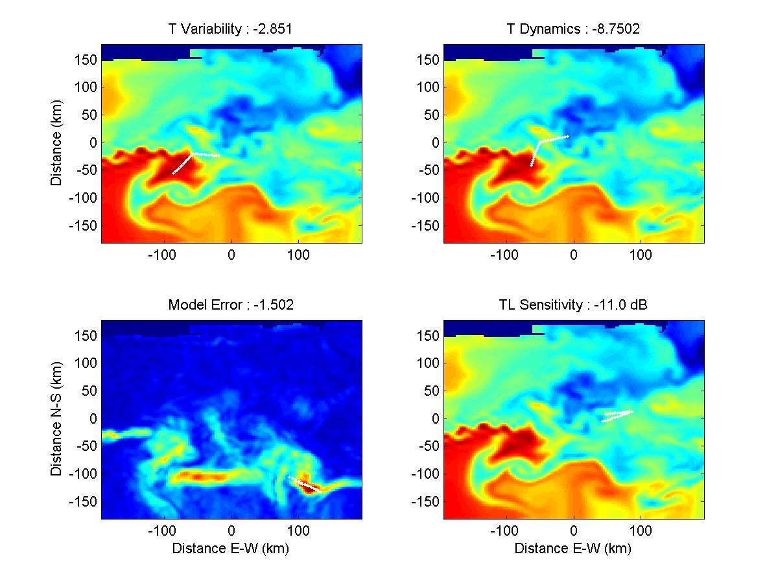
Figure 5. Single REMUS results for Ocean Variability, Ocean Dynamic Range, Ocean Uncertainty and Transmission Loss Sensitivitiy. The color maps are temperature (top two and bottom bottom right, ºC) with color axis: [15 26] and temperature uncertainty (bottom left, ºC) color axis: [0 2].

To begin to investigate this problem, the TL was computed using the Parabolic Equation (Navy Standard RAM[8]) for each platform path (a 40 km path was used for the fixed moorings). The range dependent sound speed field at the deployment day was used as the initial Sound Speed Profile (SSP), and the sound speed field at day 5 was used as the final day. In order to compare Transmission Loss and not be dominated by the interference of multipath (which Dyer showed should lead to a standard deviation around 5.6 dB), we performed range-smoothing (10% of the range). This is equivalent to a 20 Hz bandwidth average at 200 Hz[9]. Range smoothing is significantly more efficient than computing the broadband acoustic field. The cost function metric is the average of the point-by-point difference for regions with TL less than 110dB. This last threshold is put in to limit the regions of variability to be those where we expect signal. Note that in the nulls of a TL field, the differences could easily be 10-15 dB, and this result is insignificant to the problem.
The GA result for a single sensor using only the TL cost function is shown in Fig 5 (lower right panel). This is not a location of high surface dynamic oceanography, or of signifcant surface uncertainty. This is because the TL depends on the vertical variations (not shown) of the temperature, salinity and pressure and not so much on the surface values of these properties (fields at depths were not used in the previous GA examples). The value of the cost function for this path is -11.041 dB which is a significant average TL difference (remember we are doing the equivalent of a 20 Hz band averaging). To illustrate the magnitude of this TL difference: in many environments, the TL drops as a function of range according to 10log(r). In this environment, a 10 dB difference in TL is an order of magnitude difference in range of detection of a quiet target (all other variables being fixed). Thus a target would be detectable at 20 km rather than 2 km for a 10 dB error in prediction.

To diagnose what happened to produce an average TL difference of 11 dB, the range and depth-dependent oceanography along the path of the vehicle was examined. The mixed layer is deeper (30-50m) at t=0, and there is the presence of the shelf-break front for the last 30 km of the path. The shelf-break front isn’t affecting the net TL difference however. It is clear that the deepened mixed layer at t=0 leads to the situation where energy is refracted towards the bottom and stripped out of the water column. With a shallower mixed layer at t=5 days, and the presence of some warm water near the sea-floor at 20-25km, the sound is able to survive the bottom interactions and propagation over the shelf into deeper water.

This example illustrates the need to incorporate acoustic sensitivity, or at least three-dimensional ocean fields, in any oceanographic measurement and model system, usllay referred to as Ocean Observing and Prediction System [REF5]. If this particular portion of the environment is not well modeled, acoustic predictions can be off by as much as 15 dB.

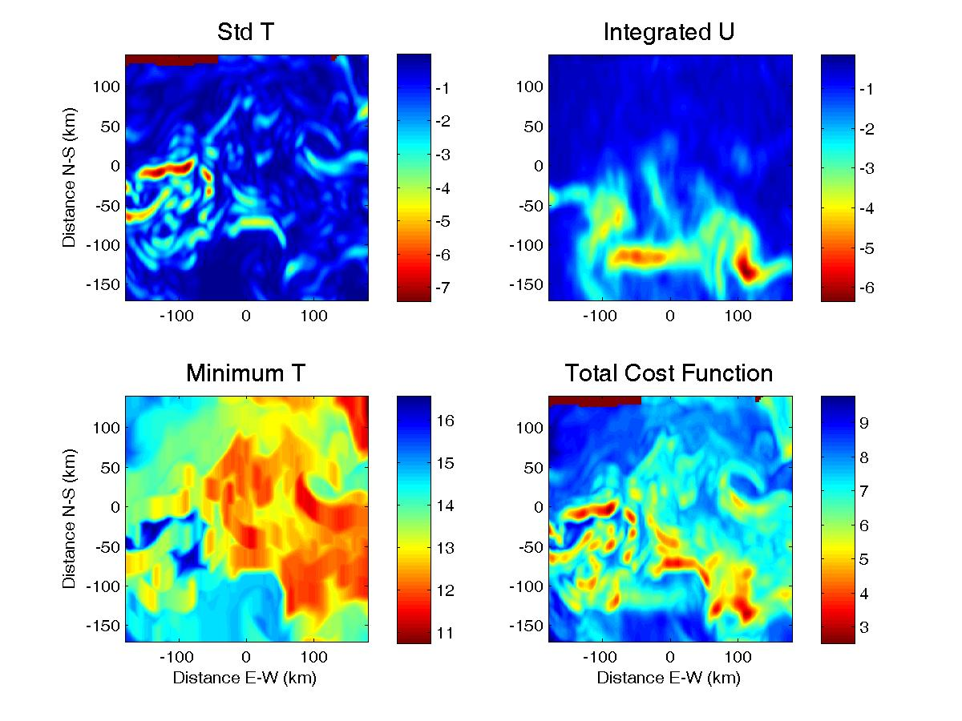
Prior to running the multi-platform, multi-parameter cost-function, we perform a simple examination of the topograhy of the cost-function. In general the cost function is a function of multiple parameters (launch position, launch direction, turns) and multiple vehicles. To examine the form of the cost function, we will search over initial position of a single platform, which samples a 20 km path oriented due North. The cost functions associated with the temperature dynamics, the minimum tempertaure and the integrated uncertainty, as well as the weighted sum of the normalized cost functions are shown in Fig. 6.

Figure 6. Cost function topology for the Standard Deviation of the measured temperature on day 30, the integrated uncertainty on day 15 and the minimum measured temperature on day 30. The normalized, combined cost-function is plotted in the lower right panel. The only independent variables in the computation are the single platform starting position.

Multiple-platform Combined Cost Function Run
With the cost function options now defined, a run of the GA for a full suite of 8 sensor platforms and a linear combination of all 5 cost functions is conducted. The sensor suite includes 3 moorings, simultaneously deployed with 3 gliders for 5 days and 2 REMUS vehicles (for 24 hours only). Each of the first 5 cost functions Ocean Variability, Ocean Dynamics, Ocean Uncertainty, TL sensitivity and Sensor Range Potential was given an equal weighting.

The full GA solution is shown in figure 7. The proof that this is the optimal sensor deployment will require a significant amount of Monte-Carlo modeling and ocean data-assimilation and is left for future work. The results are qualitatively appealing however. Note that all three moorings have been placed directly on the shelf-break front (which passes over them during the 5 days of deployment). The REMUS vehicles both pass over manifestations of the break and the Gliders track large gradients with time. The distance potential also appears to be performing its task of maintaining sensor placement beyond a Rossby radius (15 km in this example).
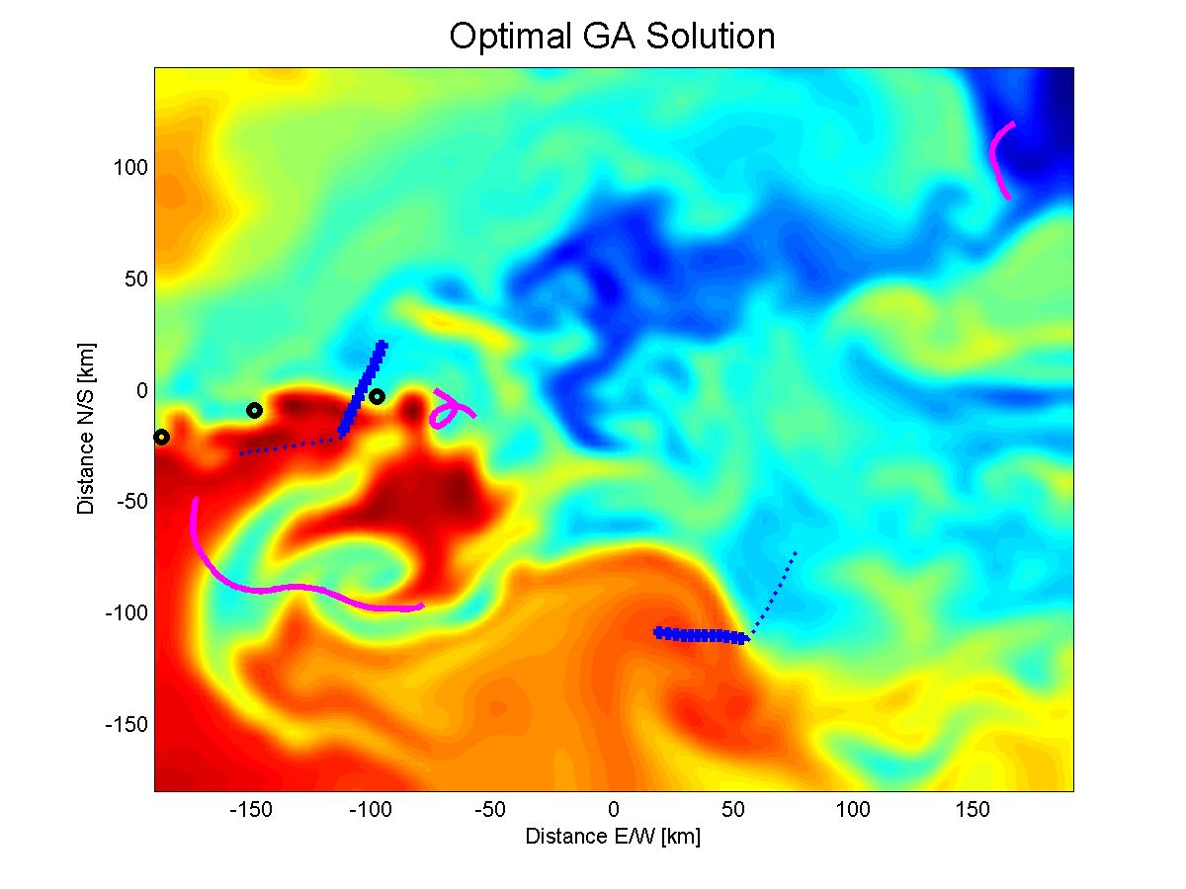
Figure 7. Genetic Algorithm solution for 3 moorings, 3 gliders and 2 REMUS vehicles. Note how the moorings (o) are located near the shelf-break front, the REMUS vehicles and the gliders cross over major fronts. The blue tracks are REMUS vehicles and the magenta tracks are gliders. [ADD SYMBOL FOR LAUNCH POINT FOR GLIDERS AND REMUS]

Note that every sensor begins its survey in cold water and ends the survey in warm water, highlighting the effect of the min/max value in the cost function as well as the standard deviation. The exception to this is platform 4 (a 24 hour REMUS deployment) which does the reverse.

- CONCLUSION
In this paper, a combined model-adaptive sampling-data assimilation approach is presented for optimal sensor placement and ocean-acoustic modeling in a dynamic oceanographic region. Two AUV platforms were developed for autonomous sampling of the oceanographic field and acoustic propagation properties. The successful deployment of these vehicles off the coast of New Jersey in the summer of 2005 is presented. A non-linear constrained optimization algorithm, based upon the Genetic Algorithm, was developed and applied to a simulated example of multi-platform sensor sampling of the dynamic ocean. Five different cost functions were developed and applied separately to this problem. The cost functions were ocean variability, ocean dynamic range, ocean uncertainty, sensor distance potential and transmission loss sensitivity. A major advantage of this technique rests in the ability to add normalized mutliple scalar cost functions, providing the user with the ability to weight the final cost function based upon his own specific needs.

One of the significant questions to be answered in model based optimization is how “optimal” is the solution. Without an extensive set of measurements this is impossible to verify. Note that this is still true if a model is not formally utilized in the planning: one can not quantitatively determine if chosen measurement sites are ideal without additional (large) data sets. Another question relates to the optimality of the solution computed by the GA algorithm. Even though the algorithm is global and designed to avoid local minima, its final solution is not garanteed to be the optimum of the chosen cost function. In addition, the final generation of the GA depends on the rules chosen to determine how new generations are formed during the optimization process. Nonetheless, there are counter-agurments to these two questions. First, the use of a model to predict the ocean and acoustic variables is quantitative and today becoming better than guessing what the future ocean and acoustic conditions will be. Similarly, the sampling strategies provided by our GA approach so far are intuitively pleasing, combine all of the features we wish to optimize, are consistent with the deployment constraints and are obtained automatically and efficiently by a computer.

The examples we have provided above to illustrate our new approach were all numerical simulations. To further evaluate the capabilities and validity of the approach, real at-sea exercises should be carried out. Such exercises would sample the ocean using our GA-based path planning and the GA would define its cost function based on the real ocean measurements and the data-driven real-time model predictions of ocean and acoustic fields and uncertainties.
[REWRITE a shorter version of LAST PARAGRAPH TO BE MORE GENERIC AND NOT ABOUT SW06]
To this end, the authors plan to conduct an extensive test of the combined model-adaptive sampling-data assimilation system in the late summer of 2006. The Office of Naval Research is sponsoring the Shallow Water 2006 Test, a multi-program, multi-institution sea test in the same region of the Mid-Atlantic Bight. During this month long test, a substantial amount of oceanographic data (over 40 moorings, 6 fixed path gliders, ship-based CTD, XBT and scanfish measurements) along with fixed and mobile acoustic sources and receivers will be deployed. The Harvard Ocean Prediction System will be spun up (with initial data from a pre-test initialization cruise) and will assimilate portions of the oceanographic measurements on a daily basis. The Genetic Algorithm will be run and for several days (those available) the “optimal” sampling measurements taken by REMUS, OMAS and ship-based Scanfish CTD) measurements will be taken. The suite of measurements will provide the opportunity, after the test, to perform a numerical study to determine the value added to the ocean prediction for each measurement.

Acknowledgments
We appreciated the useful comments from the the anonymous reviewers. PFJL thanks P.J. Haley and W.G. Leslie for discussions.
This work was funded by the Office of Naval Research under grant: …. for Heaney; … for Duda; etc
and N00014-05-1-0335 and N00014-05-1-0370 for PFJL.

REFERENCES

[1] A. R. Robinson, P. F. J. Lermusiaux, and N. Q. Sloan, "Data Assimilation," in The Sea, vol. 10, K. H. Brink and A. R. Robinson, Eds.: John Wiley & Sons, 1998, pp. 541-593.
[REF1] A.R. Robinson and P.F.J. Lermusiaux, 2004. Prediction systems with data assimilation for coupled ocean science and ocean acoustics. Theoretical and Computational Acoustics, A. Tolstoy, et al. (Eds.), 325-342.
[REF2] P.J. Haley, P.F.J. Lermusiaux, W.G. Leslie, A.R. Robinson, 2006. The Harvard Ocean Prediction System (HOPS), http://oceans.deas.harvard.edu/HOPS/HOPS.html.
[REF3] Lermusiaux P.F.J., C.-S. Chiu, G.G. Gawarkiewicz, P. Abbot, A.R. Robinson, R.N. Miller, P.J. Haley, W.G. Leslie, S.J. Majumdar, A. Pang and F. Lekien, 2006. Quantifying Uncertainities in Ocean Predictions. Oceanography, Special issue on “Advances in Computational Oceanography”, T. Paluszkiewicz and S. Harper, Eds., 19, 1, 92-105.
[2] N. M. Patrikalakis, J. J. McCarthy, A. R. Robinson, H. Schmidt, C. Evangelinos, P. J. Haley, S. Lalis, P. F. J. Lermusiaux, R. Tian, W. G. Leslie, and W. Cho, "Towards a Dynamic Data Driven System for Rapid Adaptive Interdisciplinary Ocean Forecasting," in Dynamic Data Driven Application Systems, F. Darema, Ed. Netherlands: Kluwer Academic Publishers, Submitted.
[REF4] Lermusiaux P.F.J., 2006a. Uncertainty Estimation and Prediction for the Interdisciplinary Ocean. Special issue of the Journal of Computational Physics on ``Uncertainty Quantification''. James Glimm and George Karniadakis, Editors. 176-199.
[3] P. F. J. Lermusiaux, "Application of the Error Subspace Statistical Estimation (ESSE) system to real-time error forecasting, data assimilation and adaptive sampling off the Central California Coast during AOSN-II," presented at 20th Conference on Weather Analysis and Forecasting/16th Conference on Numerical Weather Prediction, Seattle, 2004.
[4] D. E. Goldberg, Genetic Algorithms in Search, Optimization and Machine Learning. Boston: Addison-Wesley, 1989.
[5] G. Gawarkiewicz, K. Brink, F. Bahr, R. Beardsley, M. Caruso, J. Lynch, and C.-S. Chiu, "A Large -Amplitude Meander of the Shelfbreak Front south of New England: Observations from the Shelfbreak PRIMER Experiment." J. of Geophysical Research, C03006, doi:10.1029/2002JC001468, 2004.
[REF5] Lermusiaux P.F.J, 2006. Adaptive Sampling, Adaptive Data Assimilation and Adaptive Modeling. Special issue of the J. of Inverse Problems on ``Mathematical Issues and Challenges in Data Assimilation for Geophysical Systems: Interdisciplinary Perspectives''. Christopher K.R.T. Jones and Kayo Ide, Eds.
[6] S. Glenn and O. Schofield, "Observing the Oceans from the COOL Room: Our History, Experience, and Opinions," Oceanography, vol. 16, pp. 37-52, 2003.
[7] N. Yilmaz, "Path Planning of Autonomous Underwater Vehicles for Adaptive Sampling," in Department of Mechanical Engineering, vol. PhD. Cambridge: Massachusetts Institute of Technology, 2005, pp. 244.
[REF6] Yilmaz N.K., C. Evangelinos, P.F.J. Lermusiaux and N. Patrikalakis, 2006. MILP Path Planning of AUVs for Adaptive Sampling. IEEE Ocean Engineering. Under review.
[REF7] Robinson A.R., P. Abbot, P.F.J. Lermusiaux and L. Dillman, 2002. Transfer of uncertainties through physical-acoustical-sonar end-to-end systems: A conceptual basis. In “Acoustic Variability, 2002''. N.G. Pace and F.B. Jensen (Eds.), Saclantcen. Kluwer Acad. Press, 603-610.
[REF8] Abbot P. and Dyer I., Sonar Performance Predictions Based on Environmental Variability, In “Acoustic Variability, 2002”. N.G. Pace and F.B. Jensen (Eds.), SACLANTCEN. Kluwer Academic Press (2002) pp. 611-618.
[8] M. Collins, "A split-step Pade solution for the parabolic equation method," Journal of the Acoustical Society of America, vol. 93, pp. 1736-1742, 1993.
[9] C. H. Harrison and J. A. Harrison, "A simple relationship between frequency and range averages for broadband sonar," Journal of the Acoustical Society of America, vol. 97, pp. 1314-1317, 1995.

This work was funded in part by a Small Business Innovative Research (SBIR) award from SPAWAR and by the Autonomous Wide Aperture Cluster for Surveillance (AWACS) program of the Office of Naval Research.

